Week 6
MTH-1322 – Calculus 2

Hello and Welcome to the weekly resources for MTH-1322 – Calculus 2!

This week is Week 6 of class, and typically in this week of the semester, your professors are covering these topics below. If you do not see the topics your particular section of class is learning this week, please take a look at other weekly resources listed on our website for additional topics throughout of the semester.

We also invite you to look at the group tutoring chart on our website to see if this course has a group tutoring session offered this semester.

If you have any questions about these study guides, group tutoring sessions, private 30 minute tutoring appointments, the Baylor Tutoring YouTube channel or any tutoring services we offer, please visit our website www.baylor.edu/tutoring or call our drop in center during open business hours. M-Th 9am-8pm on class days 254-710-4135.

Keywords: Average Value, Mass, Density, Volume, Cross Section

Topic of the Week: More Techniques of Integration

Contents:
Highlight 1: 6.1 Area Between Two Curves
Highlight 2: 6.2 Average Value, Density, Volume
Check your Learning
Things you may Struggle With
Answers to Check your Learning
References

Highlight 1: 6.1 Area Between Two Curves

The idea behind calculating the area between two curves is straightforward. First, you must find the area under the higher curve. Then, you must subtract the area under the lower curve. The mathematical expression of this is as follows:
$$Area between 2 curves=\int_{a}^{b}{\left(f_{high}\left(x\right)-f_{low}\left(x\right)\right)dx}$$

The only time this really becomes confusing is if one curve is defined using different equations on different intervals. In this case, it will be necessary to integrate on each sub-interval with the respective equations. A single example should suffice to illustrate this principle.

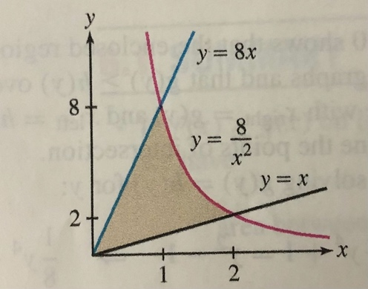
Suppose we are asked to find the area of the shaded region (Rogawski 359). We see that the lower function has the same mathematical definition across the entire range of integration. But the upper function is defined by two different curves. To get our bounds in integration, we must find the point of intersection of the top two functions. We observe that 8x=8/x² when x=1. Applying the formula for area between two curves,
$$\int_{a}^{b}{\left(f_{high}\left(x\right)-f_{low}\left(x\right)\right)dx}=\int_{0}^{1}{\left(8x-x\right)dx}+\int_{1}^{2}{\left(\frac{8}{x^{2}}-x\right)dx}=6$$
The same principles apply when x is a function of y as when y is a function of x.

Highlight 2: 6.2 Average Value, Density, Volume

To calculate the average value of any finite count of numbers, one sums them all and divides the result by the original count. One may do the same thing for the Riemann sum for a function, and then take the limit as the number of “slivers” approaches infinity. This results in the following intuitive formula for calculating average value (height) of a function.
$$Average Value=\frac{1}{b-a}\int_{a}^{b}{f\left(x\right)dx}$$

In physics, a problem frequently arises in which one would like to calculate the mass of a 1-dimensional object, such as a rod, but whose density is variable along its length. Density is in units of mass/length, so if we can multiply this by something in units of length, we ought to get something in units of mass, which is what we are after. But density, in this scenario, is variable. How do we multiply two things when one of them is constantly changing? We integrate. Specifically, we integrate the function that describes the density of the rod at any one point with respect to the length of the rod. Thus, if p(x) is the density function, the total mass of the rod between two points is
$$M=\int_{a}^{b}{p\left(x\right)dx}$$

Problems also arise in which one would like to find the volume of a 3D geometrical object. We can approach this sort of problem with our good old 2D integral, with just one added step. In 2 dimensions, we found area by integrating height of a curve (f(x)) with respect to width (dx). This is just a general way of multiplying height by width when height is changing. Of course, width times height gives us area, which is why the 2D integral returns the area under a curve. The case is similar for getting volume, except volume is thought of as the product of area and width where area is constantly changing. Therefore, to calculate volume, we must integrate area with respect to width: $V=\int_{a}^{b}{A\left(x\right)dx}$.

From geometry, one will recall that area is calculated in different ways for different shapes. This multiplicity is going to result in a multiplicity of methods of calculating the volumes of more complex solids, depending on their component areas.

A helpful way to intuit this concept is to think about volume using cross sections. Just as one can approximate the area under a curve with a sum of rectangular slivers, one can approximate the volume of a solid (a sphere, let’s say) with stacked “pancake-like” discs. With this intuition, one can already calculate the volume of simple 3D objects such as a pyramid or a cone, although more complex volume computations will be made in the following chapters.

Example: What is the volume of a pyramid that is 12m high with a square base of side 4m?

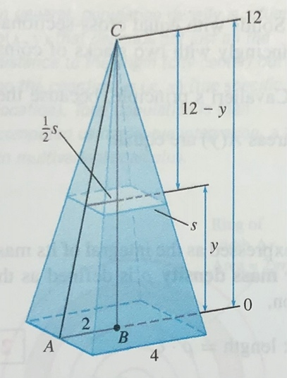
We see that the cross sectional at any height is just a square, whose area is calculated from side². After a little thought, we notice we can express the side at a given height as follows:
$s=\frac{1}{3}(12-y)$. We needed “s” expressed as a function of “y” because “y” is the variable with respect to which we will be integrating. Squaring the term gives us the area of the cross sectional. Integrating, by the formula, we obtain
$\int_{0}^{12}{\frac{1}{9}{(12-y)}^{2}dy}=64 m^{3}$ (Rogawski 367).

Check Your Learning

1. What is the area enclosed by the following curves:
$$x+y=4 , x-y=0 , y+3x=4$$

2. What is the total mass of a 2-meter rod whose linear density function is $p\left(x\right)=\frac{12}{x+4}$ kg/m for $0≤x≤2$ ?

3.
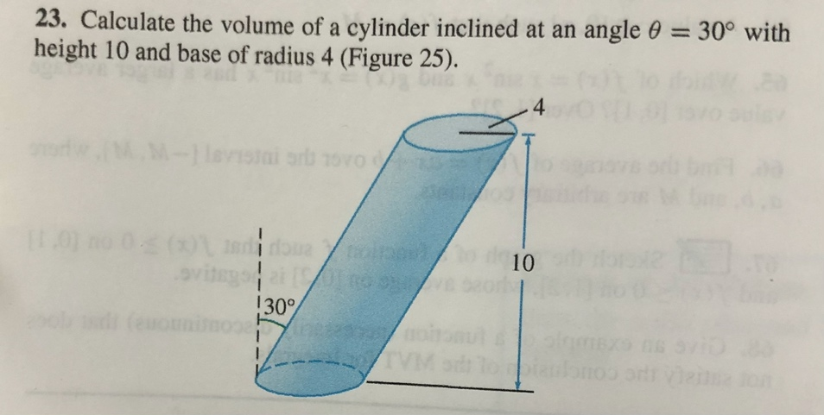 (Rogawski 375)

Things you may Struggle With

1. Mass- when doing any physics-related integration, do not get confused by the technical words. Just recognize what units things are in, what units the answer needs to be in, and accordingly, what kind of integration is needed to get there. Because integration is generalized multiplication, integrating one variable with respect to another returns something in units that are the product of the units of the two variables.

2. Volume- The key to these straightforward volume problems is to figure out how to express the geometry of the solid in terms of a function. In other words, we are trying to express the area of the cross section as a function of the length along which we are integrating.

Answers to Check Your Learning

1. 2

2. 4.87 kg

3. 160π

References
Rogawski, Jon, et al. Calculus: Early Transcendentals. W.H. Freeman, Macmillan Learning, 2019.

