Week 7
MTH-1322 – Calculus 2

Hello and Welcome to the weekly resources for MTH-1322 – Calculus 2!

This week is Week 7 of class, and typically in this week of the semester, your professors are covering these topics below. If you do not see the topics your particular section of class is learning this week, please take a look at other weekly resources listed on our website for additional topics throughout of the semester.

We also invite you to look at the group tutoring chart on our website to see if this course has a group tutoring session offered this semester.

If you have any questions about these study guides, group tutoring sessions, private 30 minute tutoring appointments, the Baylor Tutoring YouTube channel or any tutoring services we offer, please visit our website www.baylor.edu/tutoring or call our drop in center during open business hours. M-Th 9am-8pm on class days 254-710-4135.

Keywords: Solid of Revolution, Cross Section, Disk Method, Shell Method

Topic of the Week: More Techniques of Integration

Contents:
Highlight 1: 6.3 Washer Method
Highlight 2: 6.4 Shell Method
Check your Learning
Things you may Struggle With
Answers to Check your Learning
References

Highlight 1: 6.3 Washer Method

The textbook defines Solid of Revolution as “a solid obtained by rotating a region in the plane about an axis” (Rogawski 376). This concept signifies the special case where a 3D object can be completely defined as simply the rotation of some mathematically describable figure from a 2D plane. Thus, if we can figure out the equations describing the original 2D figure, we ought to have all the information we need to find the volume obtained from rotating it. The formula to do this is as follows:
$$V=π\int_{a}^{b}{{f(x)}^{2}dx}$$
where f(x) is the radius, or the distance between the curve and the x-axis (axis of rotation).

This formula will enable us to calculate the volume of solids obtained from rotating a single function around the x-axis — a parabola or a square root for example. But what if we want to find the volume of a more complicated solid — for example a doughnut-like solid? Similar to the area between two curves, to find the volume of a solid obtained from rotating an area enclosed by two curves, we will need to add the volume from the first (or outer) curve and subtract the volume from the second (or inner) curve. In other words, for rotations about the horizontal (x) axis,
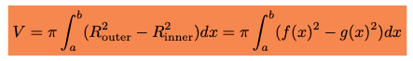
And the variable of integration simply switches to y for rotations about the vertical axis.

For example, what is the volume of f(x) = 9 – x² rotated about the vertical axis x=3 (between 0 and 9)? Since we are rotating about a vertical axis, we know we must end up integrating with respect to y. Therefore, we must express our function(s) in terms of y:
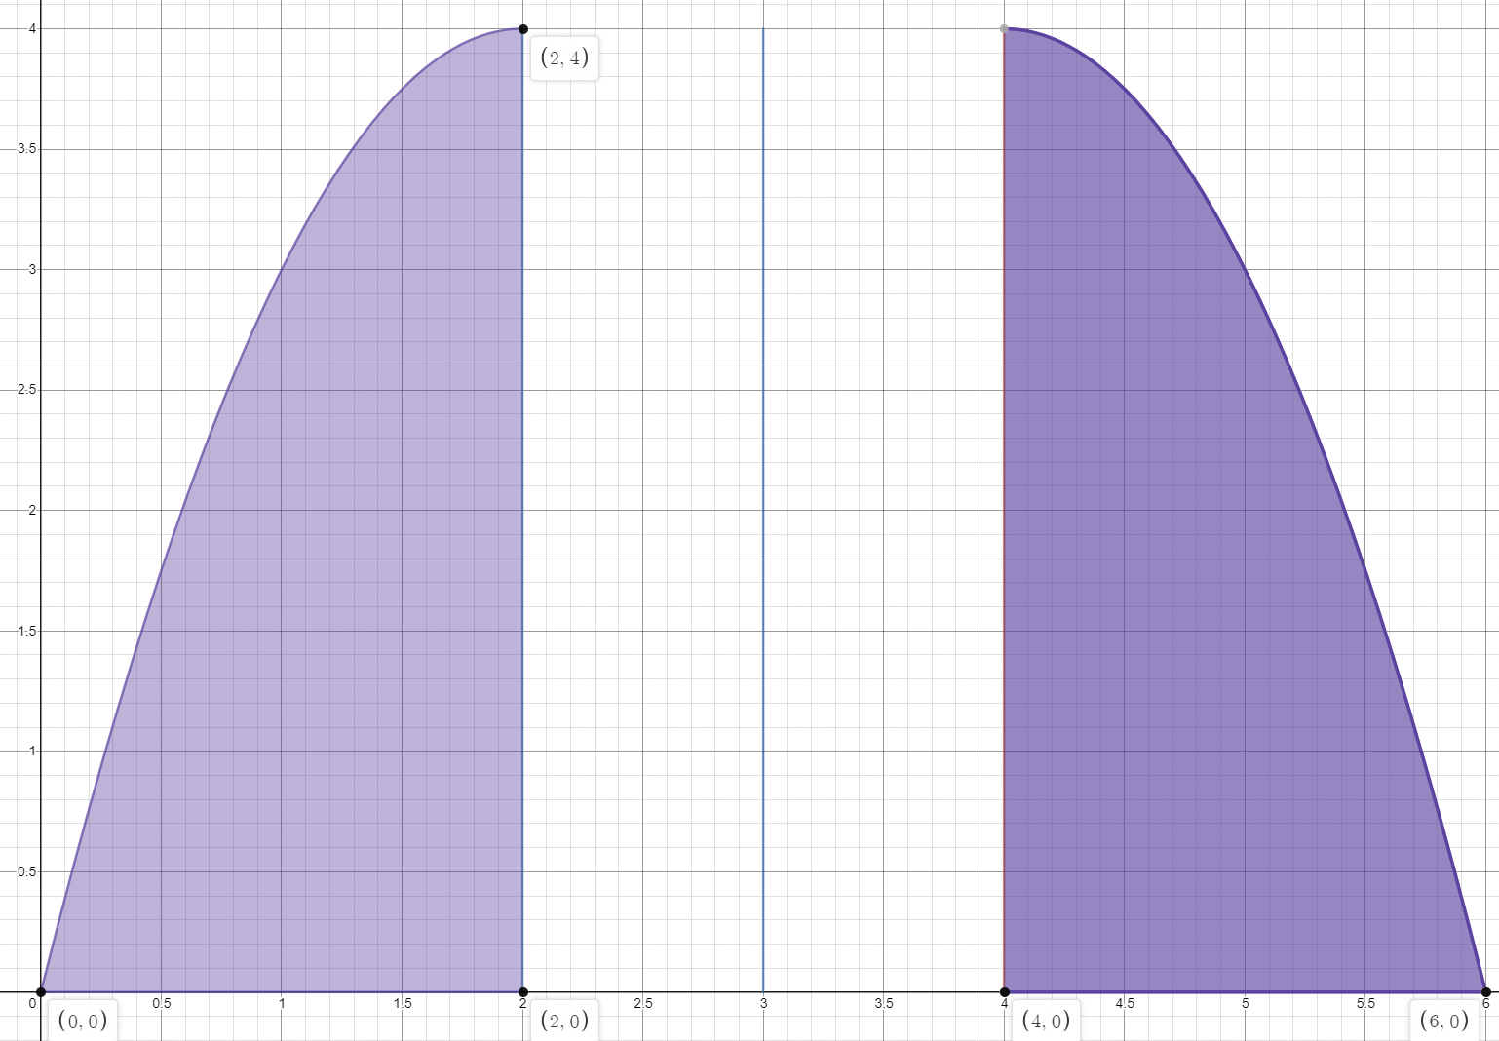

What is our outer radius? Since our axis of rotation is x=3, our outer radius is $\sqrt{4-y}+2$. What is our inner radius? It’s not explicitly stated, but we know that the square root function will not take negative values, so there is a discontinuity where y=4. Thus, the inner radius is 1. Applying our washer formula,
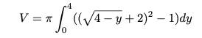
Getting the decimal answer is not so important as understanding how to assemble the above integral.

Highlight 2: 6.4 Shell Method

The formula for the shell method is as follows,
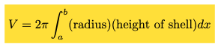
One will notice the formula for area of a circle concealed in this equation. Indeed, like the washer method, the shell method will be useful for calculating the volume of circular solids.

Suppose we have the following shape,
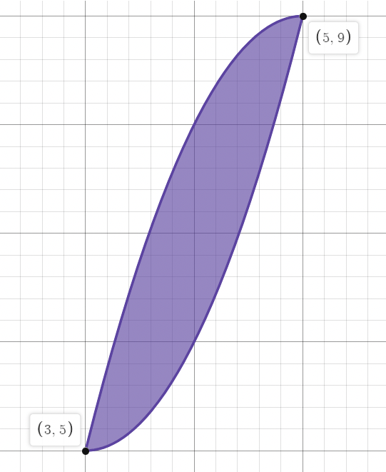

defined by the equations , and we must find the volume of rotation about the y-axis. Applying the shell method formula, we have
Again, understanding how the integral is set up is more important that actually calculating the volume.

If one struggles with an intuition for these concepts, one can always simply apply the formula, as we have done above. But an intuition is always helpful. This is an abstract concept, and the fact that it is 3D makes it difficult to convey on paper. The textbook, however, does a pretty good job of illustrating exactly what is being integrated in each case and why said integration should result in the calculation of the desired area (Lewicki 6.3 and 6.4).

Check Your Learning

1. Find the volume of $f\left(x\right)=\frac{2}{x+1}$ rotated around the x-axis on the interval [1,3] using the disk method (Rogawski 382).

2. Find the volume of the solid obtained from rotating the region enclosed by y=x², y=12-x, and x=0 about y=-2 for x>0 using the disk method (Rogawski 383).

3. Find the volume of the solid obtained from rotating the region enclosed by y=x², y=8-x², x=0 about the y axis for x>0 using the shell method.

Things you may Struggle With

1. Difference between methods- One way to conceptualize the difference between the disk and shell method is to consider the geometry of the underlying integrand. The Disk Method takes the area of a circle for its integrand and integrates it along the axis of the washer. The Shell Method takes the area of the (curved) rectangle as its integrand and integrates it from the center of the shell outward. See textbook for illustrations clarifying the this distinction.

2. Washer Method- It is easy to lose track of the axis of rotation. It is not always simply the x or y axis. It will always be a vertical or horizontal axis, but it might be x=3 or y=7, or some other constant. Some students even prefer to rewrite the equations such that everything is translated over to the x or y axis. This technique can clean up the algebra quite a bit, and it works because the volume of a solid is the same whether you leave it where it is or translate it over a few units.

Answers to Check Your Learning

1. π

2. $\frac{1872π}{5}$

3. 16π

References
Rogawski, Jon, et al. Calculus: Early Transcendentals. W.H. Freeman, Macmillan Learning, 2019.
All disk and shell problems are taken from Ethan Reyes’ tutoring resources.

