Finding Retention Model Scores and Predicted Intervention Level

- Retention Model Score is for incoming classes (Fall 2021 & Spring 2022 Admit Term Cohorts).
- Predicted Intervention Level is for all other admit terms.

On Student Profile:
- Find the Predicted Intervention Level on the grey box at the top of the profile:
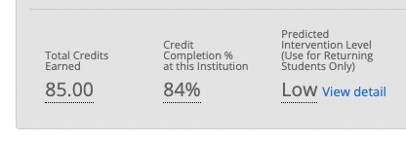

- Find the Retention Model Score in the Tags section toward the bottom of the student profile overview page.
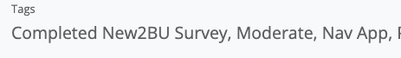

For entire class(es):
- Retention Model Score:
  - Advanced Search:
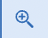

  - Student Information (select the RMS you would like to know about):
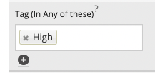

  - Enrollment History:
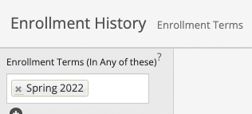

  - Term Data Professor (your name):
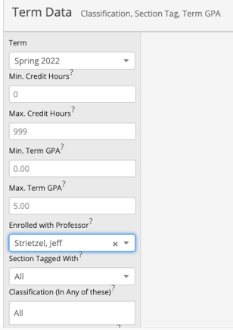

  - Search.
  - Your results will show all the students in your class(es) that have the RMS you selected in the tag portion.

- Intervention Effectiveness Score
  - Advanced Search:

  - Enrollment History:

  - Term Data Professor (your name):

  - Success Indicators
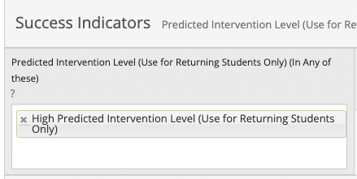

  - Search.
  - Your results will show all the students in your class(es) that have the Predicted Intervention Level you selected in the Success Indicators portion.

