- Choose the Appointments tab in Navigate:
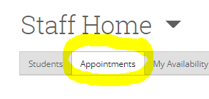
- Select the appointment for the student who did not show up:
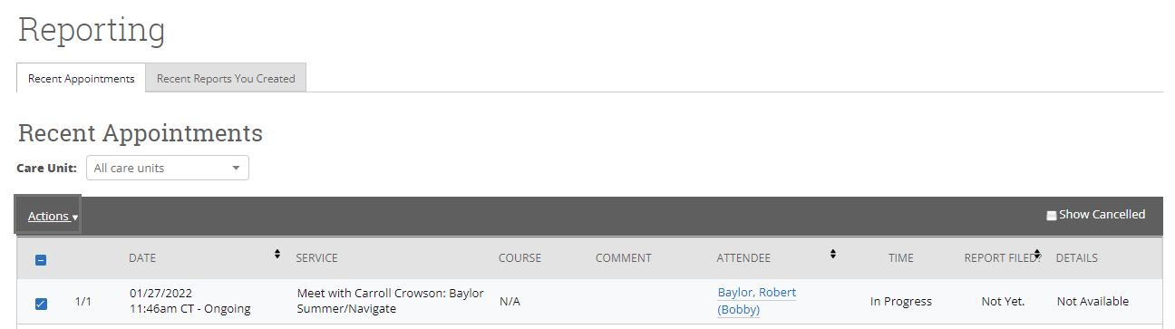
- Choose "Add Appointment Summary” from Drop Down Menu:
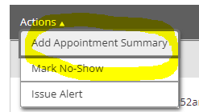
- Uncheck the “Attended” box for the student and save.
