**Using Model Scores for**

**Intervention with Students**

***Recommended best practices:*** Given time pressures and our commitment to provide equal access to a quality Baylor education, it is recommended that you prioritize the most personalized care for students at high and moderate risk for leaving the next fall. This can mean giving the high/ moderate risk students the first opportunity to sign up for advising appointments. Or, if you are trying to get to know all of the students in one of your classes, consider having a face-to-face meeting with high risk students whereas an email exchange might suffice for a low risk student. Low risk students tend to be more self-directed and find resources with not as much guidance.

**New Students: Utilize IR’s Retention Model Scores**

Baylor’s IR office created Retention Model Scores for our new students, both transfers and new first-year students. When you are on a student’s profile, look in the “Tags” section. For every new student, in Navigate, you should see “Low,” “Moderate,” or “High.” “Low” means that the student has a low chance of leaving Baylor next fall whereas “High” means that the student has a high chance of leaving Baylor. You can also use the Advanced search feature and pull for example, students in your area who have the “High” tag.

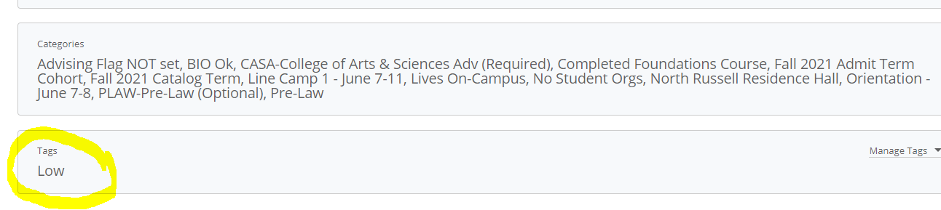

Here are the variables that IR found to be most significant for new students this fall:

|  |  |
| --- | --- |
| First-Year Students | New Transfers |
| First-generation status  In-state  Living on/off-campus  Academic index  AP scores of 3+  Deposit date  High school retention rate  Unit retention rate | First-generation status  In-state  Living on/off-campus  Deposit date  Unit retention rate  Transfer GPA |

*Important Note:* Retention Model Scores with associated Tags will be updated in mid-October based on Progress Reports and New2BU data.

**Continuing Students: Utilize EAB’s Intervention Levels**

For continuing students, use the model scores (called “Intervention Level”) that you find at top of an enrolled student’s profile page.

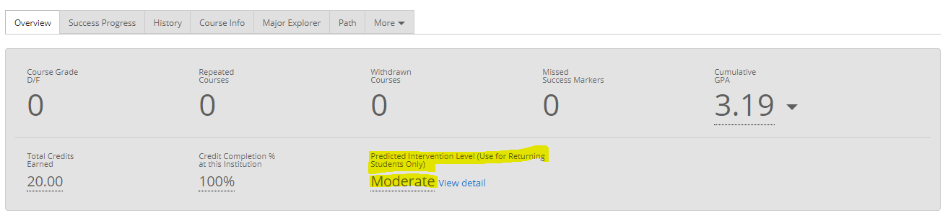

Here are the variables that Education Advisory Board (EAB) found to be most significant for our continuing students:

* Number of completed terms
* Average credits attempted per term
* Ratio of earned to attempted credits
* Cumulative GPA
* Recent change in GPA
* Term GPA earned during first term
* Proportion of transfer credits
* Admit code
* Total number of D/F grades earned
* Number of D/F grades earned in previous term
* Number of W grades earned in previous term
* Trend in term GPA

**Important Reminder:** These indicators are not predictors; neither do they represent a student’s destiny. They should be used, in combination with other information you have, to help staff prioritize how to spend their time and approach conversations with students. In short, with our focused attention, we can assist the higher risk students to beat the odds and succeed at Baylor. This is a beautiful manifestation of our caring community at work in smart and strategic ways.