Preparing for and Attending Your
ONLINE TUTORING SESSION

PRIOR TO THE START OF YOUR APPOINTMENT, be sure you have done the following:

- Download Zoom and become familiar with how to use the app on your personal device of choice.

- To get Zoom, follow this link to the Zoom platform downloads available for a laptop (or use your cell phone’s version of the Appstore and download Zoom as an app).

- For instructions on how to use Zoom, refer to the tutorials below, or use video resources provided here.

- Once you have downloaded Zoom, gather your course materials, (notes, online textbook, canvas course instructions, etc.) and have them accessible during your session. If you have never used Zoom before, have a friend download the app as well and practice using the app. Make sure you have read the PDF below to practice using the in app tools.

On the date and time of your tutoring appointment:
- Be in front of your computer with Zoom open and ready to attend your session.

- Your tutor will invite you to join their Zoom meeting prior to the start of your tutoring session using your Baylor email address. They will share the necessary link, meeting ID, and meeting passcode with you; however, you are responsible for performing what is necessary to follow the link and join the session.

- At this stage, you should receive a message that you are in the waiting room for your tutor’s meeting. Your tutor will be notified that you have arrive into their waiting room and they will accept you into the session. Please be patient if the previous appointment ended a few minutes late. Tutors will do their best to end a call on time so they can address the next waiting appointment.

TOOLS WITHIN THE SESSION TO USE:

Within Zoom you have several items you can use to communicate. You can use the chat to share a link or a small piece of information. Beyond that, Zoom’s most popular tools for tutoring sessions are:

~SHARING YOUR SCREEN – for sharing a website or something else you want your tutor to see from your computer
~SHARING A WHITE BOARD – for sharing a live drawing or writing surface
~SHARING A DOCUMENT – passing a document to your tutor to see

The next few pages will walk you through how to access these three different tools.

SHARING YOUR SCREEN
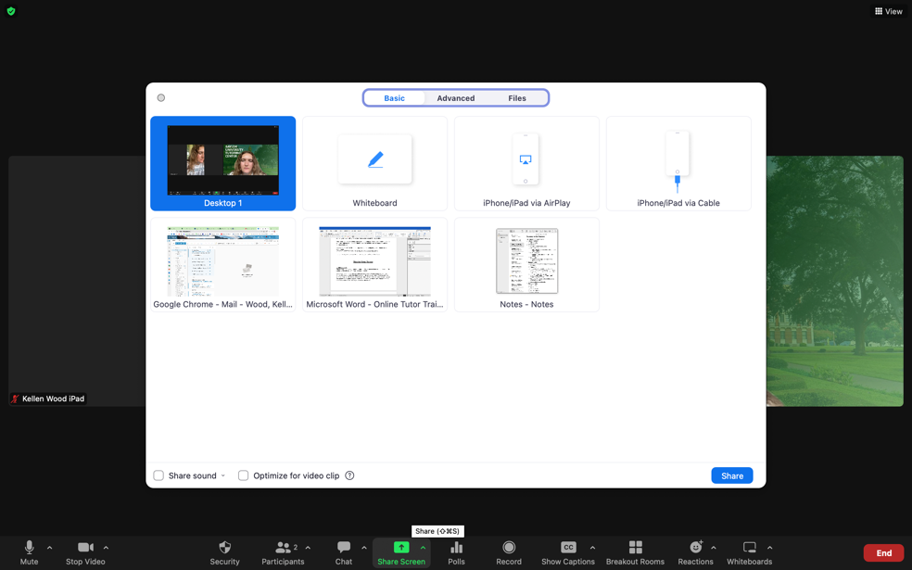

You can work on your screen to point out important information on a document, diagram, etc, and each of you will be able to see all of your movements in real time.

To share your screen, click on the button that says “Share Screen” from the panel at the bottom of the screen >> select the window you would like to share (or desktop if you have multiple windows) >> then click “share” to officially begin sharing your screen. If you share the desktop, please be aware that the other person will be able to look at everything you have open in your computer, so please ensure you do not have material or information not related to the tutoring session or material that you do not wish others to see. You can see a visual of this directly above.

USING THE WHITEBOARD
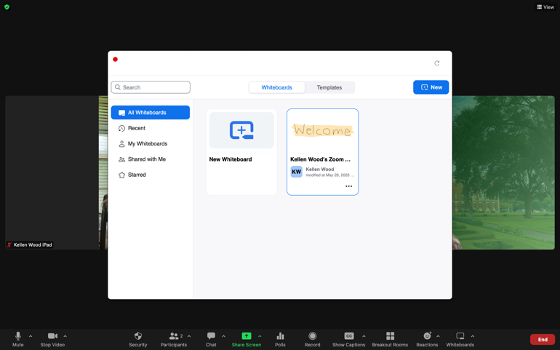

A whiteboard is an interactive screen which functions much like shared chalkboard or glass board would on the wall. It is a drawing or writing surface that participants can use.

To open the Whiteboard tool, select the “Whiteboards” icon from the panel at the bottom of the screen. Decide whether you’d like to work on a preexisting whiteboard, or if you want to open a new whiteboard. This action will open a “whiteboard” screen where you can draw diagrams in real time. Even if you are not sharing your screen, the tutor will be able to see your drawings and follow your explanations as you draw. You can see a visual of this directly above and below.
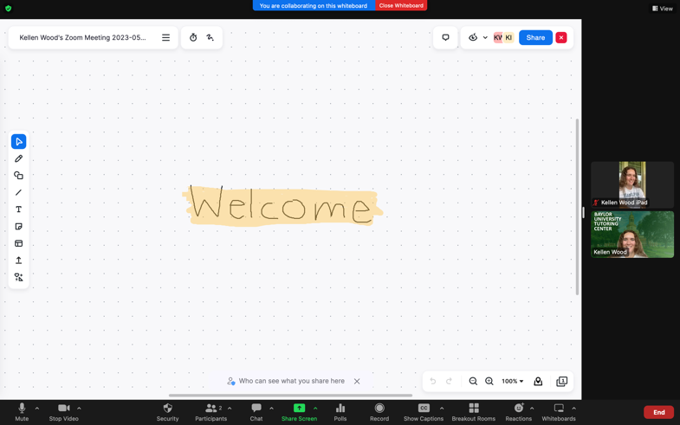

SHARING A DOCUMENT

You might find that you wish to send a document to the tutor. Here is how you would do that.

To share a document:
Step 1: Open the chat function by clicking on its appropriate button from the icon panel
Step 2: Select the third button option which should read “file”. It looks like a piece of paper.
Step 3: Find the file that you wish to share with your tutor and import it into the chat so that they may have access to view the shared document.

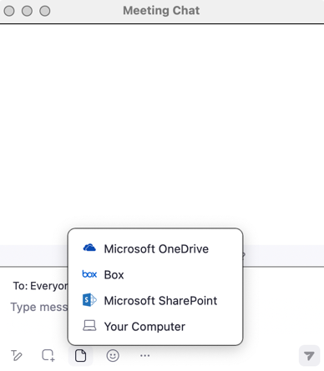

The tutor will wrap up your session after 25 minutes to make it to their next appointment. Have a great session!

