Week 14
ACC 2303 – Financial Accounting
Hello and welcome to the weekly resources for ACC 2303!
This week is Week 14 of classes, and typically in this week of the semester, your professors are covering these topics below. If you do not see the topics your particular section of class is learning this week, please take a look at other weekly resources listed on our website for additional topics throughout the semester.
We also invite you to take a look at the group tutoring chart on our website to see if this course has a group tutoring session offered this semester.
If you have any questions about these study guides, group tutoring sessions, private 30-minute tutoring appointments, the Baylor Tutoring YouTube channel or any tutoring services we offer, please visit our website www.baylor.edu/tutoring or call our drop-in center during open business hours, M-Th 9am-8pm on class days, at 254-710-4135.

Keywords: Statement of Cash Flows, Operating Activities, Investing Activities, Financing Activities, Direct & Indirect Cash Flows

Topic of the Week: Statement of Cash Flows

Highlight #1: Statement of Cash Flows

The Statement of Cash Flows is a financial statement that measures how an organization uses their cash. This statement has four main purposes:
- To predict future cash flows
- Evaluate management decisions
- Determine the ability to pay interest or dividends
- Show the relationship between net income and cashflows with the business
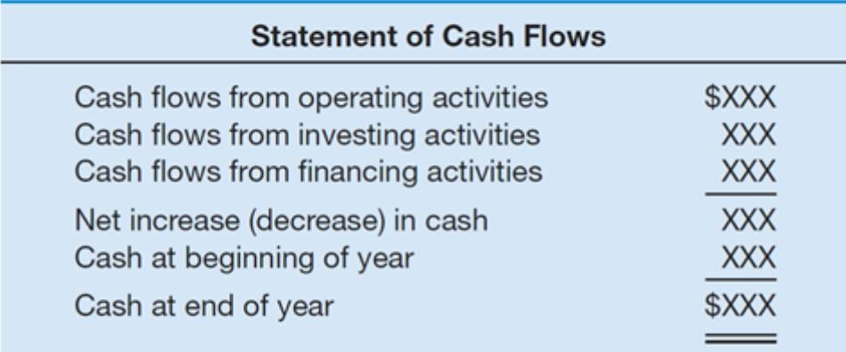
The following image provides an overview of the structure and contents of the Statement of Cash Flows.

Highlight #2: Types of Cash Flows and Business Activities
The statement of cash flows measures three different types of business activities: operating, investing, and financing.

Operating are cash flows involved in everyday operations
Examples:
Inflow: any revenue-related account like sales revenue
Outflow: expenses like paying rent

Investing are cash flows related to long-term assets
Examples:
Outflow: Buying a building
Inflow: Selling PPE

Financing are cash flows resulting from long-term liabilities and equity
Examples:
Outflow: Issuing debt
Inflow: Paying debt

The following graphic is helpful in identifying which cash transactions go under which type of cash flow
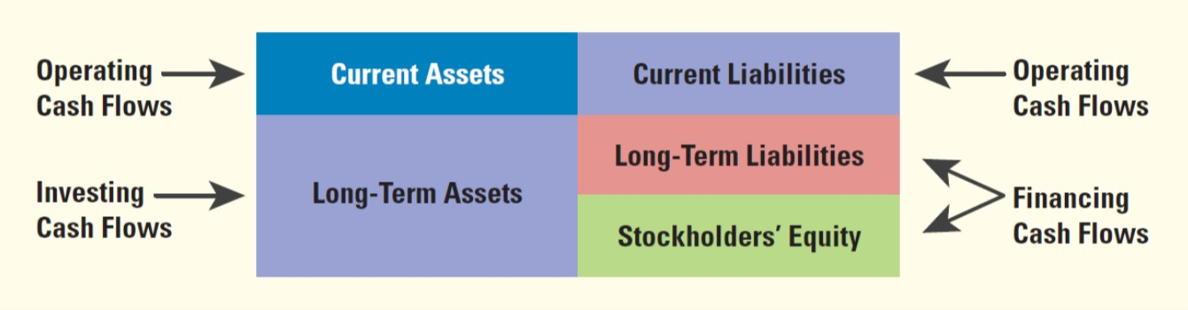
Types of Cash Flows:
Direct: everyday transactions like paying employees
Indirect: these cash flows reconcile the difference between net income and net cash. For example, depreciation decreases net income without impacting cash. So, to get an accurate picture of net income in relation to net cash we would have to add depreciation back into cash.

Highlight #3: Preparing the Statement of Cash Flows:
When preparing a statement of cash flows, you will follow the formula in the image below.
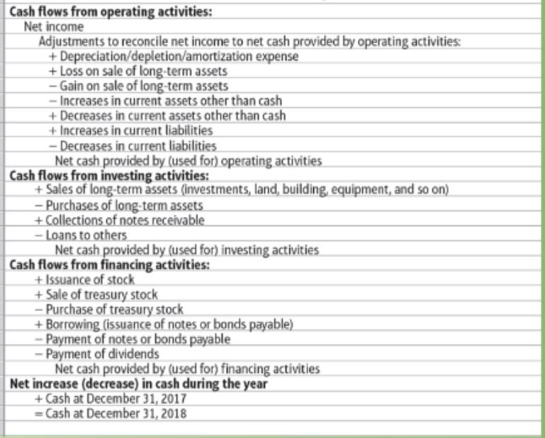
Note: Think about how each situation impacts cash and that will be how you add or subtract. Do pay special attention to what you do with the indirect cash flows like depreciation and gains and losses.
The following video shows a great way to think about this formula and how to create a statement of cash flows:
https://www.youtube.com/watch?v=pt9cB30gxmg&feature=youtu.be

Highlight #4: Notes for the Final
Statement of Cash Flows and Equity are the only new sections on the final. As such, make sure you know how to deal with them.
There will be an FSA portion on the exam. Review your ratios!
Review complicated calculations like bonds (Week 11), depreciation (Week 10), treasury stock (Week 13), bank recs (Week 7), etc.
Go and look to see what you got wrong on the previous exams and build your review from there.
Complete the practice final, practice multiple choice, and old quizzes. Identify problem areas. If you need more problems, do the party favors!
If you are having trouble with a particular topic, you can look at the resources I have created for each topic or go to edspira.com for a video explanation

Check Your Learning:
- True or false: Indirect cash flows are everyday transactions such as paying employees.
  - True
  - False

- Which of the following is not a main purpose of the statement of cash flows?
  - To predict future cash flows
  - Evaluate management decisions
  - Determine the ability to pay interest or dividends
  - All of the answer choices are main purposes of the statement of cash flows

- Long-term assets transactions are which type of cash flow?
  - Operating
  - Investing
  - Financing
  - All answer choices are correct

Things You May Struggle With:
- Accounting is like learning a language so knowing the vocabulary and practicing journal entries are important to your success.
- Know the structure of a journal entry so you don’t mix up debits and credits.
- It can be overwhelming with the amount of information you have to learn if you just memorize different scenarios. Learn the general types of journal entries so that you can apply them to different situations.

Thanks for checking out these weekly resources!
Don’t forget to check out our website for group tutoring times, video tutorials, and lots of other
resources: www.baylor.edu/tutoring ! Answers to check your learning questions are below!

Answers to Check Your Learning:

      - B
      - D
      - B

