Week 10
ACC 2303 – Financial Accounting
Hello and welcome to the weekly resources for ACC 2303!
This week is Week 10 of classes, and typically in this week of the semester, your professors are covering these topics below. If you do not see the topics your particular section of class is learning this week, please take a look at other weekly resources listed on our website for additional topics throughout the semester.
We also invite you to take a look at the group tutoring chart on our website to see if this course has a group tutoring session offered this semester.
If you have any questions about these study guides, group tutoring sessions, private 30-minute tutoring appointments, the Baylor Tutoring YouTube channel or any tutoring services we offer, please visit our website www.baylor.edu/tutoring or call our drop-in center during open business hours, M-Th 9am-8pm on class days, at 254-710-4135.

Keywords: Capitalizing Costs, Lump Sum Purchases, Depreciation, Straight-line, Units of Production, Double Declining, Intangible Assets, Goodwill

Topic of the Week: Capitalization vs. Expensing

Highlight #1:
Most costs incurred by a business are expensed meaning that they are recorded as expenses and subtracted directly from Net Income on the Income Statement.
Capitalizing Costs refers to recording costs associated with an asset as part of the asset itself instead of recording these costs as expenses on the income statement. These assets are then allocated over time so that these expenditures can be smoothly dispersed as expenses to the income statement. Capital expenditures are usually quite large and would therefore inject a high amount of volatility into Net Income if they were treated as regular expenses.
A general rule of thumb for determining what to include in a capital asset is that a capital asset is the sum of the acquisition costs and the costs to bring the asset to its intended use.
As assets are used up and generate revenue, the correct amount of expense should also be recorded in the same period to follow the Matching Principle.
The following chart illustrates how expensing and capitalizing costs impact the financial statements:

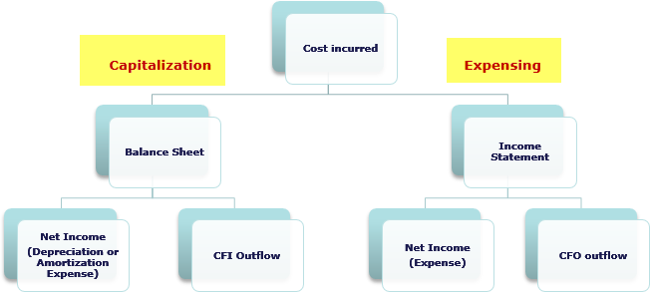

Highlight #1: Main Capital Asset Accounts
The main capital asset accounts are: Land, Land Improvements, Buildings, and Machinery and Equipment.
The Land account includes the following costs: Purchase price, Brokerage fees, Survey fees, Legal fees, Back property taxes, Expenditures for grading and clearing land, and removing unwanted buildings (Subtract off salvage material). Note: Land is NOT depreciated.
The Land Improvements Account includes the following costs: Driveways, Fences, Sprinkler System, Signage, and Lighting. Note: Land Improvements ARE depreciated.
The Building account includes the following costs: Architectural fees, building permits, Contractor fees, Payments for materials, labor, overhead, Interest on loans for construction, Purchase price of existing building, Brokerage commission, Sales and other taxes, Expenditures to repair and renovate building (prior to bringing to intended use).
The Machinery and Equipment Account includes the following costs; Purchase Price (minus any discounts), Transportation from seller, Insurance while in transit, Sale tax and other taxes, Purchase Commission, Installation Costs, Testing costs, and Special flatforms (ex. Mounting machinery).
For more on capitalization and some examples of calculations, take a look at the following video:
https://youtu.be/zOmwJ_GpdQ0 (Edspira.com)

Highlight #2: Lump Sum Purchases
Lump Sum Purchases happen when multiple capital assets are purchased at once. To record this, we allocate the purchase price across the assets based upon their market price.
Example:
Baylor, Inc. purchased some land that already had a warehouse and an office building. It was purchased for a lump sum of $400,000. The market values are appraised at $200,000 for the land, $75,000 for the warehouse, and $225,000 for the office building. At what cost will the land, warehouse, and office building be recorded at?
Solution: We divide the cost into “buckets” by using the following equation:
Lump sum * (Market price of asset / Total Market Price of all assets in purchase)
Answers:
Land: 400,000 * (200,000/500,000) = $160,000
Warehouse: 400,000 * (75,000/500,000) = $60,000
Office Building: 400,000 * (225,000/500,000) = $180,00
$400,000
Note: The lump sum values for each account should add up to the lump sum purchase price

Highlight #3: Depreciation
Depreciation is a method used to allocate expenses associated with an asset over its useful life. Note that this is NOT a method of valuation.
Terms Associated with Depreciation:
- Depreciable cost = Asset Cost - Estimated Residual Value
- Accumulated Depreciation: a contra-asset account that records the amount of depreciation over time
- Book Value = Asset Cost – Accumulate depreciation. This is the amount recorded on the balance sheet for a depreciable asset
- Estimate Useful Life: length of service expected from asset that can be measured in years, units of output, miles, or some other unit.
- Estimate Residual Value: Also known as scrap or salvage value, this is the cash value of the asset at the end of its life. This value is NOT depreciated.

Journal Entry for Depreciation:
DR: Depreciation Expense $$$$
CR: Accumulated Depreciation $$$$

Highlight #4: Methods of Calculating Depreciation Expense
Straight-Line is when Depreciation will be equal each period as it is allocated by useful life. Best used when asset generates its value equally over time (same value in year 1 than year 7).
Formula: (Asset Cost – Salvage Value) / Useful Life
Example:
Bob has a truck that cost $10,000 has a useful life of 9 years and a salvage value of $1000. Calculate depreciation expense for each period and the book value for two years down the road using straight line.
Answer:
Depreciation Expense: (10,000 – 1,000) / 9 = $1,000.

JE for first and second year:
DR: Depreciation Exp: $1,000
CR: Accumulated Depreciation: $1,000.

Book value after two years = $10,000 (original cost) - $2,000 (Accumulated Depreciation).

Units of Production Depreciation Expense is allocated based on the units produced (activity level). This method is the most precise but can be tendious to manage.
Formula: ((Asset Cost – Salvage Value) / Useful life (in units of production)) * actual amount of units produced during period
Example:
The cookie monster has a cookie machine that cost $20,000, has a salvage value of $2,000, and can produce 6,000 cookies over its useful life. Calculate depreciation expense if the cookie monster made 4000 cookies this period using units of production.
Answer:
((20,000 – 2,000)/6,000) * 4,000 = $12,000

Double Declining Balance is an accelerated method of depreciation that writes off a larger amount of depreciation towards the beginning of the asset’s life. A common mistake is to subtract out a salvage value, do NOT do this. DDB does not consider salvage values until the last year where the salvage value will be the ending book value and the depreciation expense will be the difference between the salvage value and the calculated depreciation expense for that year. Best used if the asset is expected to be most useful in the first few years and less useful the older it gets.
Formula: 2 * (1 / useful life) * Book Value of Asset
Example:
As a hypothetical example, suppose a business purchased a $30,000 delivery truck, which was expected to last for 10 years. After 10 years, it would be worth $3,000, its salvage value. Calculate Depreciation Expense using double declining balance.
Answer: New BV
Year 1: 2 * (1 / 10) * 30,000 = $6,000 $24,000
Year 2: 2 * (1 / 10) * 24,000 = $4,800 $19,200
Year 3: 2 * (1 / 10) * 19,200 = $3,840 $15,360

Another way to think of each of these methods is to look at their behavior graphically overtime. Straight line has a linear behavior as its depreciation is the same each year, units of production have a varied behavior that depends upon actual output, and DDB has an exponential behavior. See the graph below to see this in action.

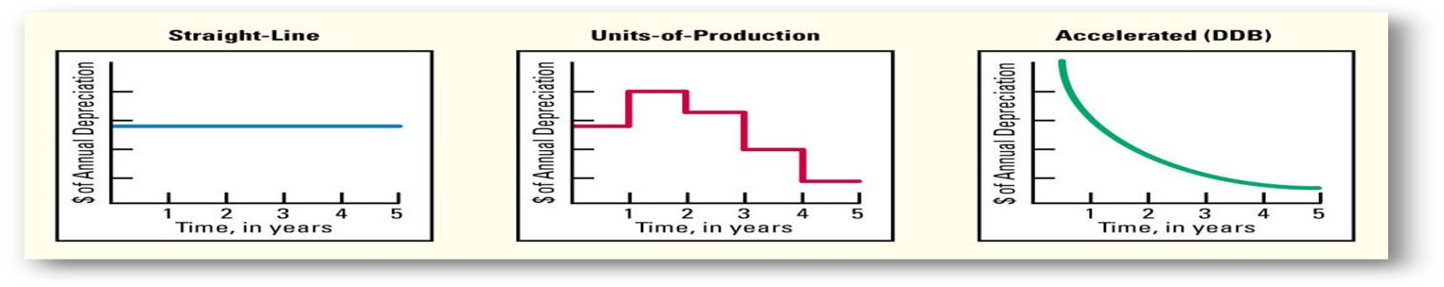

Highlight #5: Accounting for Natural Resources
Resources are depleted using the same formula/method as units of production depreciation If ALL of the resources are sold the amount depleted is recorded as an expense (e.g. COGS). If any of the resources are not sold, this amount is recorded as inventory.
Intangible Assets are legal rights to use or own that does not have a physical form. Examples: Patents, copyrights, franchises, trademarks, and goodwill. These assets are recorded at cost (Purchase price – fees). These assets are amortized using the same formula as straight-line depreciation. Note: Useful life is the Shorter of legal period or useful life.
JE for amortization:
DR: Amortization Expense $$$$
CR: Intangible Asset $$$$

Goodwill is a special intangible asset recorded when a company purchases another company at a price greater that the Net Assets of the acquired company.
Formula: Goodwill = Purchase Price – Net Assets
Note: Only record goodwill when Price > net assets (equity)

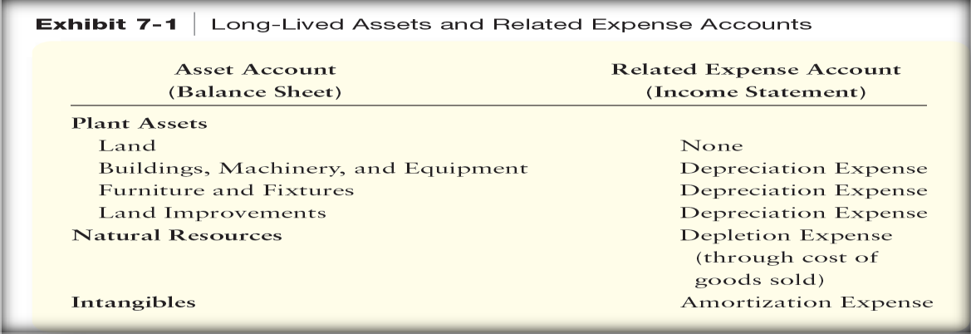

Check Your Learning:
- Which of the following is not an example of a land account cost?
  - Purchase price
  - Brokerage fees
  - Back property tax
  - Lighting

- True or false: Lump Sum Purchases happen when multiple capital assets are purchased at once.
  - True
  - False
- True or false: The following journal entry is the correct format for depreciation expense
DR: Accumulated Depreciation $$$$
CR: Depreciation Expense $$$$
  - True
  - False

Things You May Struggle With:
- When using double declining balance don’t forget to take Last year’s book value minus Acc. Depreciation to get your book value of asset.
- Remember how to set up the journal entries for depreciation and amortization.

Thanks for checking out these weekly resources!
Don’t forget to check out our website for group tutoring times, video tutorials, and lots of other
resources: www.baylor.edu/tutoring ! Answers to check your learning questions are below!

Answers to Check Your Learning:

      - D
      - A
      - B

