Week 11
ACC 2303 – Financial Accounting
Hello and welcome to the weekly resources for ACC 2303!
This week is Week 11 of classes, and typically in this week of the semester, your professors are covering these topics below. If you do not see the topics your particular section of class is learning this week, please take a look at other weekly resources listed on our website for additional topics throughout the semester.
We also invite you to take a look at the group tutoring chart on our website to see if this course has a group tutoring session offered this semester.
If you have any questions about these study guides, group tutoring sessions, private 30-minute tutoring appointments, the Baylor Tutoring YouTube channel or any tutoring services we offer, please visit our website www.baylor.edu/tutoring or call our drop-in center during open business hours, M-Th 9am-8pm on class days, at 254-710-4135.

Keywords: Secured Bonds, Unsecured Bonds, Term Bonds, Serial Bond, Par, Premium, Discount

Topic of the Week: Bonds

Bond Certification
Example of Bond Certificate: 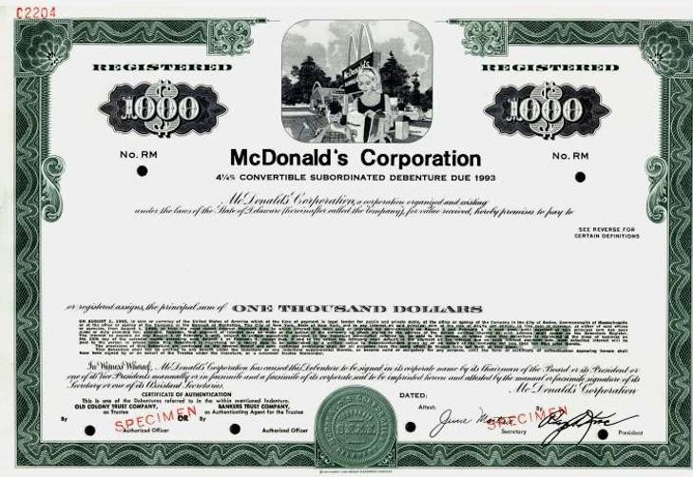

Highlight #1: Types of Bonds
Secured Bonds are backed with collateral consisting of company assets
Unsecured Bonds are backed by good faith which makes them riskier and carry a higher interest rate
Term Bonds are all mature at the same time
Serial Bonds mature in regular intervals of time

Highlight #2: Bonds Issued at Par, Premium, or Discount

Bonds contain a stated rate of interest at which the bonds are issued at. We compare this with the going market rate for bonds to determine whether the bonds should be issued at par, premium, or discount. We’ll look at the each of these situations below.

Issued at Par (Stated Rate=Market Rate), means that the bonds issuer will receive the same amount of cash as the face value of the bond (bond payable account)
JE Issuance:
DR: Cash (Face value) $$$$
CR: Bonds Payable $$$$
JE Interest Expense:
DR: Interest Expense (Face value*Rate) $$$$
CR: Interest Payable or Cash $$$$

Issued at Premium (Stated Rate>Market Rate), means the bond issuer receives more cash than the face value of the bond
JE Issuance:
DR Cash (Face value *Valuation percentage) $$$$
CR: Premium (CV-FV) $$$$
CR: Bonds Payable (Face value) $$$$
Note: Carrying Value = Face value + premium
JE Interest Expense:
DR: Interest Expense (Plug!) $$$$
DR: Premium (Discount/Term) $$$$
CR: Cash (Face value*SR) $$$$

Issued at Discount (Stated Rate<Market Rate), means the bond issuer receives less cash than the face value of the bond
JE Issuance:
DR: Cash (face value*valuation percentage) $$$$
DR: Discount (FV-CV) $$$$
CR: Bond Payable (FV*SR) $$$$
JE Interest Expense
DR: Interest Expense (Plug!) $$$$
CR: Discount (Discount/Term) $$$$
CR: Cash (Face value *SR) $$$$

In summation: We reduce the premium and the discount until the carrying value equals the face value at the end of the term of the bond.
A good way to think about issuing bonds at discount, par, or premium is to start with these questions: "What is the market charging right now?" and "How does it compare to our own stated rate?". One of three things will happen:
- Our stated rate matches the market interest rate. That's perfectly fine. No side "wins", no side "loses".
- Our stated rate exceeds the market interest rate. Our company loses that trade! We are offering a higher rate of return than anyone else on the market. As a result, we need our buyers to pay in a little more if they want to get out a little more.
- Our stated rate is less than the market interest rate. Our investors lose that trade! Why would investors bother with our investment when there are stronger alternatives available right now? The only way for the investor to receive a higher effective return is to modify one of two inputs:
Change the rate of return on the bond (no)
Lower the cost of the investment (yes!)
This is illustrated in the following graph:
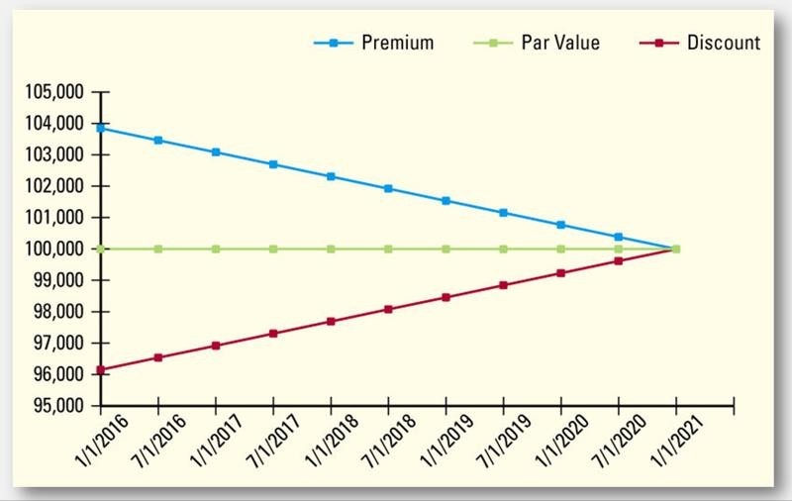

Check Your Learning:
- Which bond type is backed by good faith which makes them riskier and carry a higher interest rate?
  - Secured Bonds
  - Unsecured Bonds
  - Term Bonds
  - Serial Bonds

- If the stated rate is greater than the market rate, what should the bond be issued at?
  - Par
  - Premium
  - Discount
  - None of the answer choices
- True or False: Carrying value equals face value plus premium.
  - True
  - False

Things You May Struggle With:
- Knowing whether to issue the bond at par, discount or premium based on whether the stated value is equal to, greater than, or less than the market value.
- Remembering the formats when the bond is issued at par vs discount vs premium.

Thanks for checking out these weekly resources!
Don’t forget to check out our website for group tutoring times, video tutorials, and lots of other
resources: www.baylor.edu/tutoring ! Answers to check your learning questions are below!

Answers to Check Your Learning:

      - B
      - B
      - A

