Week 12
ACC 2303 – Financial Accounting
Hello and welcome to the weekly resources for ACC 2303!
This week is Week 12 of classes, and typically in this week of the semester, your professors are covering these topics below. If you do not see the topics your particular section of class is learning this week, please take a look at other weekly resources listed on our website for additional topics throughout the semester.
We also invite you to take a look at the group tutoring chart on our website to see if this course has a group tutoring session offered this semester.
If you have any questions about these study guides, group tutoring sessions, private 30-minute tutoring appointments, the Baylor Tutoring YouTube channel or any tutoring services we offer, please visit our website www.baylor.edu/tutoring or call our drop-in center during open business hours, M-Th 9am-8pm on class days, at 254-710-4135.

Keywords: Current Liabilities, Long-Term Liabilities, Short-Term Notes, Sales Tax Payable, Accrued Liabilities, Unearned Revenue, Warranty Expenses, Contingent Liabilities

Topic of the Week: Current and Long-Term Liabilities

Highlight #1: Current vs Long-Term Liabilities
Current Liabilities are obligations due within one year or operating cycle. There are two kinds; Estimated amounts (Think: Income taxes payable) and Known amounts (Think: Accounts payable)
Long-Term Liabilities are obligations that extend beyond one year or operating cycle.

Highlight #2: Different Types of Liabilities

Short-Term Notes are due within the year. They are used to buy assets or generate cash. Need to accrue interest expense and interest payable at the end of the payable. Interest rates are recorded at annual amounts and must be adjusted to the term of the notes.
Example:
Baylor purchases soccer equipment for $10,000 on a short-term note, with a stated rate of 12% for a term of 5 months. Give the journal entry for the purchase of the equipment and the payment of the note.
JE for Purchase:
DR: Equipment $10,000
CR: Short-Term Note Payable $10,000
JE for Payment of Note Payable:
DR: Note Payable $10,000
DR: Interest Exp (10000*.12* 5/12) $500
CR: Cash $10,500

Sales Tax Payable are levied on retail sales and are collected from customers and remitted to the state.
Example:
Home Depot store’s daily sales totaled $200,000 and an additional 8% ($10,000) of
sales tax (assume this is all in cash).
JE:
DR: Cash (200,000*1.08) $216,000
CR: Sales Revenue $200,000
CR: Sales Tax Payable (200,000*.08) $16,000

Accrued Liabilities come from expenses incurred but not paid. The typical categories of accrued liabilities are: Salary and Wages Payable, Interest Payable, or Income Taxes Payable.
JE:
DR: Accrued Expense $$$$$
CR: Accrued Liability Typical Category $$$$$

Unearned Revenue happens when a business receives cash before performing the service obligation. Results in a liability.
Example:
Bob the Tomato paid Larry the Cucumber $12,000 in to mow his lawn over the next 12 months. Record the journal entry for the sale and fulfillment of the obligation for the next month.
Payment JE:
DR: Cash $12,000
CR: Unearned Revenue $12,0000

First month:
DR: Unearned Revenue $1,000
CR: Revenue $1,000

Warranty Expenses has two steps as follows:
1st: Record estimated Warranty Expense using the following journal entry
DR: Warranty Expense (Estimated Expense) $$$$
CR: Estimated Warranty Liability $$$$
2nd: Record the actual amount of the expense using the following entry:
DR: Accrued Warranties Payable $$$$
CR: Inventory $$$$

Contingent Liabilities is a potential liability that depends on the future outcomes of past events. Some examples are lawsuits and tax disputes. We record these based on the likelihood of the liability being realized. We can only accrue the contingent liability if it is both probable in nature and the amount can be reasonably estimated.
If probable, accrue (journalize) and disclose in the notes of the financial statements
If reasonably possible, disclose in the financial statements
If remotely probable, do nothing
This is illustrated by the following table;
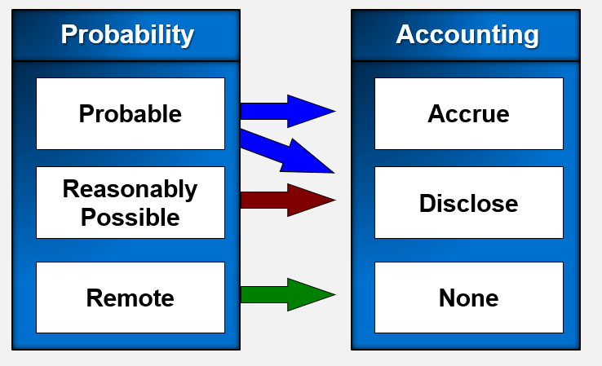

Highlight #3: Ways to Finance a Business

Bonds (Debt):
Pros:
- Does not dilute control
- Typically, higher EPS than issuing stock
- Interest Expense is tax deductible
Cons:
- Risk

Issuing Stock:
Pros:
- Avoids liabilities and interest expenses
Cons:
- Dilutes EPS
- Dilutes control of organization

Retained Earnings:
Pros:
- Low risk
Cons:
- Hard to raise large sums of cash

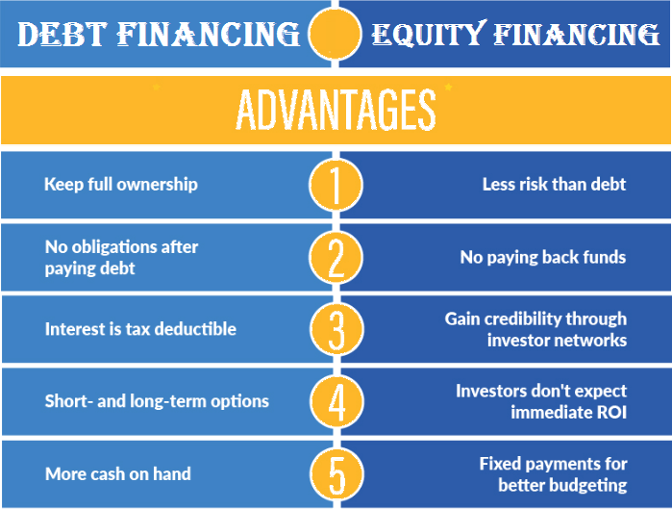

Check Your Learning:
- True or false: Current liabilities are obligations due within one year or operating cycle and long-term liabilities are obligations that extend beyond one year or operating cycle.
  - True
  - False

- Salary and Wages Payable, Interest Payable, or Income Taxes Payable are all examples of which type of liability?
  - Sales Tax Payable
  - Short-term Notes
  - Accrued Liabilities
  - Unearned Revenue

- Baylor Bookstore’s daily sales totaled $5,000 and an additional 8% ($10,000) of sales tax (assume this is all in cash). Which of the following would NOT be credited?
  - Cash for $5,400
  - Sales Revenue for $5,000
  - Sales Tax Payable for $400
  - All would be credited

Things You May Struggle With:
- Knowing how to use the tax rate to find values such as sales tax payable and interest expense
- Knowing when to record contingent liabilities. Know the image from above of if probable, if reasonably possible, and remotely probable.

Thanks for checking out these weekly resources!
Don’t forget to check out our website for group tutoring times, video tutorials, and lots of other
resources: www.baylor.edu/tutoring ! Answers to check your learning questions are below!

Answers to Check Your Learning:

      - A
      - C
      - A

