Week 13
ACC 2303 – Financial Accounting
Hello and welcome to the weekly resources for ACC 2303!
This week is Week 13 of classes, and typically in this week of the semester, your professors are covering these topics below. If you do not see the topics your particular section of class is learning this week, please take a look at other weekly resources listed on our website for additional topics throughout the semester.
We also invite you to take a look at the group tutoring chart on our website to see if this course has a group tutoring session offered this semester.
If you have any questions about these study guides, group tutoring sessions, private 30-minute tutoring appointments, the Baylor Tutoring YouTube channel or any tutoring services we offer, please visit our website www.baylor.edu/tutoring or call our drop-in center during open business hours, M-Th 9am-8pm on class days, at 254-710-4135.

Keywords: Public Companies, Private Companies, Corporate Structure, Stockholders, Stockholder’s Equity, Paid-in Capital, Common Stock, Preferred Stock, Treasury Stock, Retained Earnings, Cash Dividends, Stock Dividends, Stock Split

Topic of the Week: Corporate Structure and Equity

Highlight #1: Corporate Structure
Public companies are companies whose stock is actively traded on the stock market and are owned by stockholders.
Private companies are companies whose stock is not traded on the stock market and have a few major stockholders.

Features of a Corporation:
Advantages: easier to raise capital, continuous life and easy to transfer ownership through selling stock, and stockholders are protected from liability
Disadvantages: ownership and management have different goals, double taxation, and government regulation.
Double taxation of corporations happens because the corporation is a creature of statute. It pays taxes on its own income, and individuals are taxed on whatever they get the corporation's after-tax proceeds (i.e., dividends, liquidations, etc.).

The Corporate Structure looks as the following:
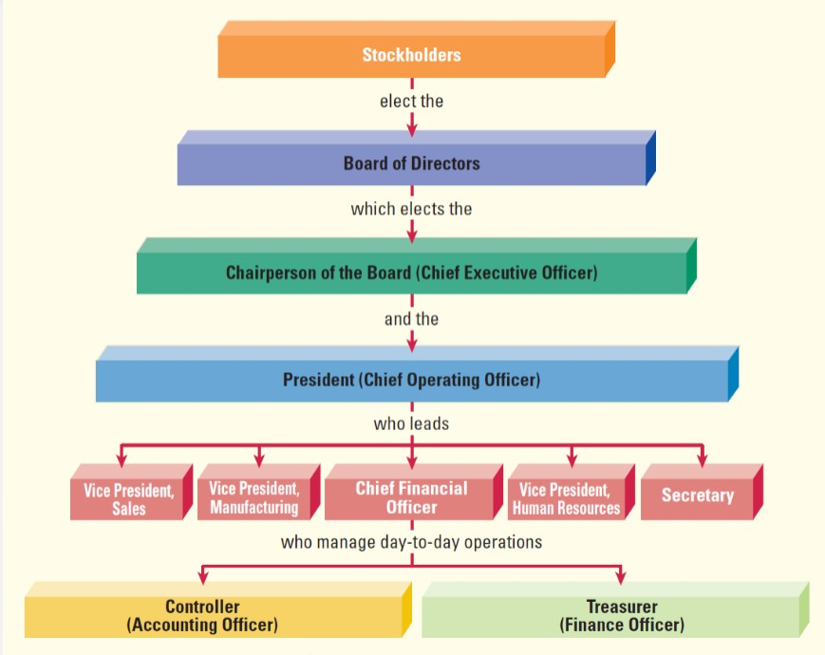

Highlight #2: Stockholder’s Equity
Stockholders are the people who have the right to vote on matters that come to stockholders, receive dividends, receive a proportionate share of assets upon liquidation of the company, and preemptively buy stock to preserve proportional control over the company.

The Stockholder’s Equity section of the balance sheet is divided into the following categories:
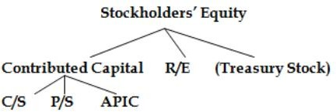

Paid-in Capital (contributed capital) is the amount of equity that stockholders have contributed to the organization through purchasing stock and paying in capital
Common Stock is the most frequent form of stock
Preferred Stock is stock that has certain benefits such as receiving dividends and liquidated assets before regular stockholders. Preferred stockholders have NO voting rights!
Treasury Stock is previously issued stock that has been bought back by the company and
reduces stockholder’s equity. This is a contra-equity account. Treasury stock also reduces the amount of Shares Outstanding because the stock is now in the hands of the company.
Retained Earnings is the amount of equity that a company produces through profitable operations. This account is reduced by dividends.

Highlight #3: Cash Dividends, Stock Dividends, and Stock Splits
For Cash Dividends company must have enough retained earnings and cash to pay dividends.
Board of director declares a date for dividends to be paid (creating a dividend payable):
JE:
DR: Retained Earnings $$$$
CR: Dividends Payable $$$$
Date of record defines when the stockholders will be paid (no Journal entry here)
Date of Payment, resolves liability and pays stockholders:
JE:
DR: Dividends Payable $$$$
CR: Cash $$$$

Stock Dividends is a similar idea to cash dividends but with stock instead of cash
Declaration Date:
JE:
DR: Retained Earnings $$$$
CR: Stock Dividends Distributable $$$$
CR: APIC (if needed) $$$$
Date of Record: NO JE
Date of Payment:
JE:
DR: Stock Dividends Distributable
CR: Common Stock (can also be preferred stock)
*Note: If less than a 25% dividend record the stock at market value. If greater than 25%, record at par value.

Stock Split situations arises when a company makes exist shares of stock into more shares. For example, a person who has 100 shares of stock and undergoes a 2:1 stock split would have 200 shares of stock after the split. There is NO journal entry here.
You are going to need to know how the following situations impact the balance sheet. This chart illustrates the effects. This chart can come in handy in a bind though and can help you think through those entries and their effect on the balance sheet
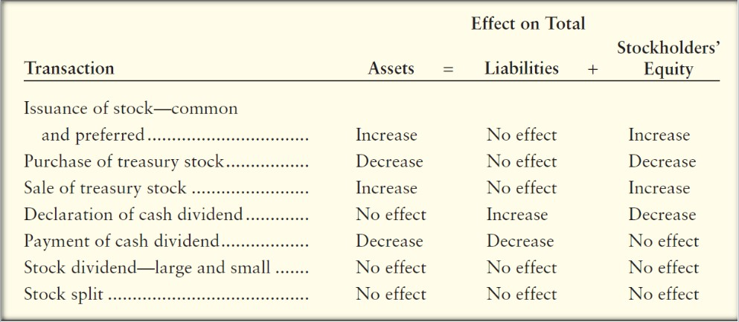
Check Your Learning:
- True or false: Treasury stock is a contra-equity account.
  - True
  - False
- True or false: APIC is needed every time to be credited in journal entries for stock dividends.
  - True
  - False

- Which of the following rights do Stockholders have?
  - Vote on matters that come to them
  - Receive a proportionate share of assets upon liquidation of the company
  - Receive dividends
  - All answer choices are correct

Things You May Struggle With:
- Knowing the difference between cash and stock dividends. Also, knowing how their journal entries are different.
- Remembering that treasury stock is a contra-equity account. Therefore, it has an opposite effect on the income statement than the other types of stockholder’s equity accounts.

Thanks for checking out these weekly resources!
Don’t forget to check out our website for group tutoring times, video tutorials, and lots of other
resources: www.baylor.edu/tutoring ! Answers to check your learning questions are below!

Answers to Check Your Learning:

      - A
      - B
      - D

