Week 3
ACC 2303 – Financial Accounting
Hello and welcome to the weekly resources for ACC 2303!
This week is Week 3 of classes, and typically in this week of the semester, your professors are covering these topics below. If you do not see the topics your particular section of class is learning this week, please take a look at other weekly resources listed on our website for additional topics throughout the semester.
We also invite you to take a look at the group tutoring chart on our website to see if this course has a group tutoring session offered this semester.
If you have any questions about these study guides, group tutoring sessions, private 30-minute tutoring appointments, the Baylor Tutoring YouTube channel or any tutoring services we offer, please visit our website www.baylor.edu/tutoring or call our drop-in center during open business hours, M-Th 9am-8pm on class days, at 254-710-4135.

Keywords: Cash vs Accrual Accounting, Revenue Recognition, Expense Matching Principles, Accrual and Deferral Adjusting Entries

Topic of the Week: Cash vs Accrual Accounting

Highlight #1: Cash vs Accrual Accounting
There are two methods of accounting that vastly differ in their treatment of transactions and their impact on the financial statements.
Cash Accounting is a method of accounting that only records cash-based transactions or when cash actually changes hands. This method is used by the smallest businesses and results in incomplete financial statements.
Accrual Accounting is a method of accounting that records the impact of any type of transaction when that transaction occurs. This method is required by U.S. GAAP (Generally Accepted Accounting Principles). The hallmark of accrual accounting is that it recognizes revenues and expenses when they occur as opposed to waiting until cash changes hands. This method will be the focus of the course.
Accrual accounting is all about recording transactions as they happen. As such, accountants report financial information at regular intervals. This is illustrated in the following graphic:
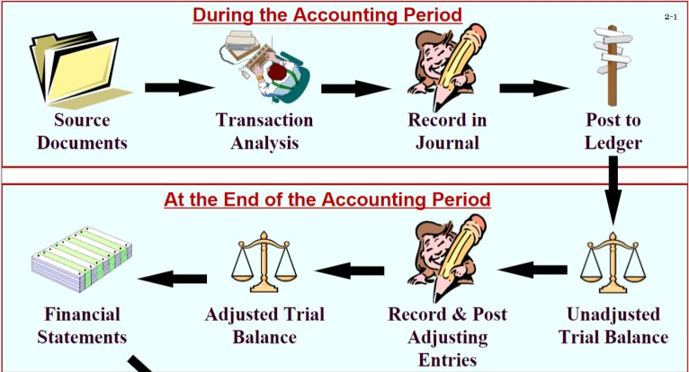
In other words, accrual accounting uses the revenue recognition and expense matching principle to record an initial transaction. As time goes on, adjusting journal entries are performed to reflect cash finally being received, an obligation being fulfilled, or a prepaid asset being used up.
The following video, created by Michael McLaughlin of Edspira.com, is another great resource if you want to learn more about the theory behind cash and accrual accounting.
https://www.youtube.com/watch?v=Of2tFsfKm_8

Highlight #2: Revenue Recognition and Expense Matching Principle
Revenue Recognition: Revenue is recognized when it is earned. Examples of this include when a firm transfers promised goods and services to a company in exchange for compensation.
Expense Matching principle: Expenses are recorded in the same period in which any corresponding revenue is recognized (i.e. expenses are matched to revenues).
Example:
On January 1st, Bob pays you $1000 to mow his lawn every month for the next year. You are supposed to start mowing his lawn on Feb 1. When will you record the revenue?
Answer: February 1. You do not recognize revenue until you fulfill your obligation. This is a classic example of a deferral.

Follow Up: If you were Bob, when would you record the expense?
Answer: February 1. One records expenses when they are incurred.

Highlight #3: Accrual and Deferral Adjusting Entries
Adjusting entries account for the passage of time and they allow expenses and revenues to be matched in a given period. These journal entries always include one revenue or expense account and one asset or liability account. They NEVER include cash. The two main types of adjusting journal entries are deferrals and accruals.
Deferrals entries provide an adjustment when cash is received in advance or when a firm pays for something in advance. In other words, cash changes hands before the adjusting entry. The most common form of deferral entries are prepaid expenses or unearned revenues.

Example JE format:
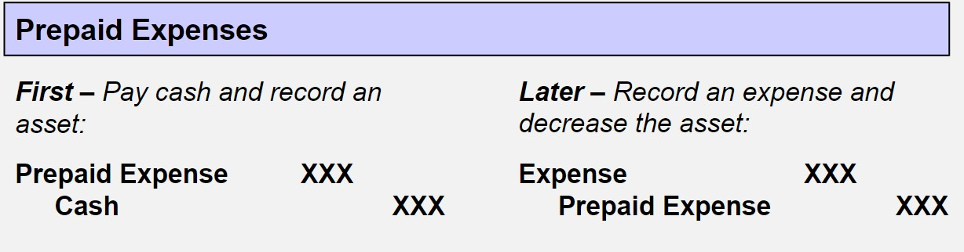
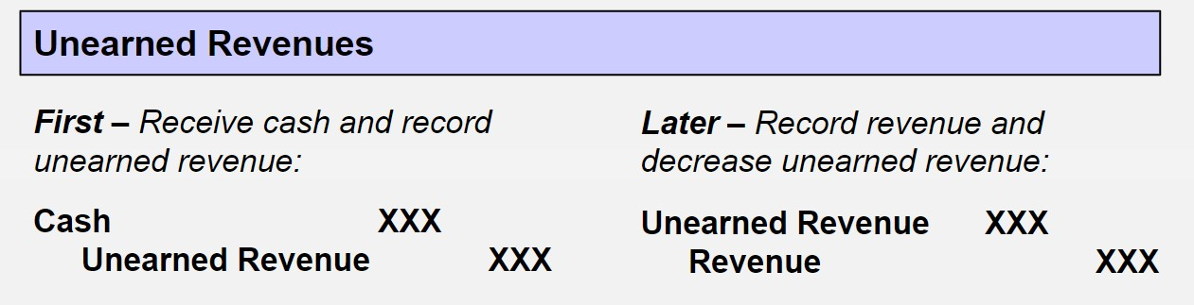
OR:

Accrual is an adjustment made to accounts before a receipt or payment of cash. In other words, expenses and revenues are recorded before cash changes hands.

Example JE format:
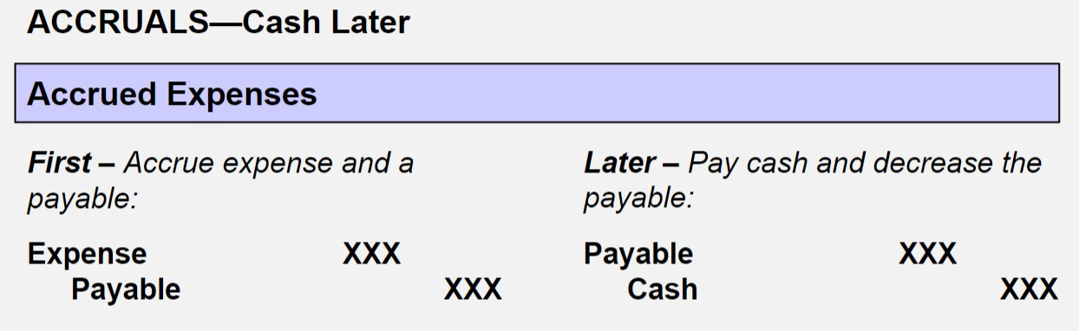
OR
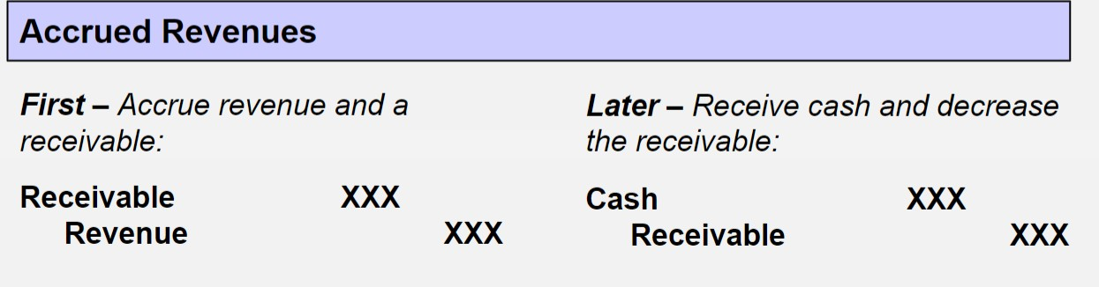
Each of the adjusting entries and their corresponding accounts are summarized in the following chart:
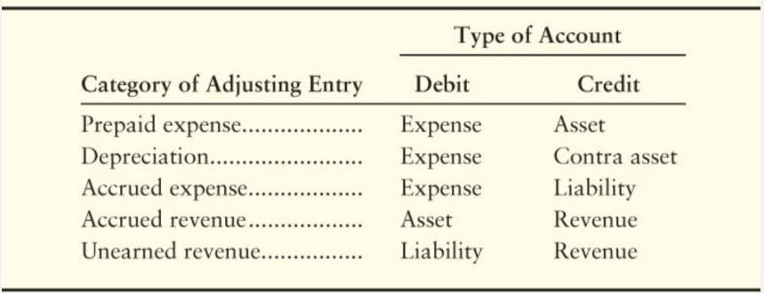
Accrual Adjusting Entry Example:
Your business makes custom tote bags. In June, you make $1,200 worth of tote bags for a client, and then you invoice them. The client pays the invoice on March 7.
Record the Original JE:
2/27/2020 DR: Accounts Receivable $1,200
CR: Revenue $1,200
Adjusting Entry:
3/7/2020 DR: Cash $1,200
CR: Accounts Receivable $1,200
Deferral Adjusting Entry Example:
Suppose Baylor paid $3,000,000 to rent the Ferrell Center from January-March on January 1st. What are the journal entries on January 1st and January 31st?
1/1/2020 DR: Prepaid Rent $3,000,000
CR: Cash $3,000,000
1/31/2020 DR: Rent Expense $1,000,000
CR: Prepaid Rent $1,000,000
* $3,000,000/3 months = $1,000,000 per month
Further Examples:
See the following videos for more help on adjusting entries, accruals, and deferrals: https://www.youtube.com/watch?v=KyjAU-yS4Lk&feature=youtu.be (Adjusting journal entry theory)
https://www.youtube.com/watch?v=C17Oc9JqG_Q&feature=youtu.be (Deferrals)
https://www.youtube.com/watch?v=xXeoGlQOV1c (Accruals)
Check Your Learning:
- True or false: According to revenue recognition, revenue is recognized when it is earned.
  - True
  - False

- True or false: Deferral entries, essentially, happen when cash changes hands after the adjusting entry.
  - True
  - False

Use the following information for questions 3-5:
Jenna Newbury began a music business in July 2018. Newbury prepares monthly financial statements and uses the accrual basis of accounting. The following transactions are Newbury Company's only activities during July through October:
- Jul 14 Bought music on account for $65, with payment to the supplier due in 90 days
- Aug 3 Performed a job on account for Alanna Turner for $55, collectible from her in 30 days. Used up all the music purchased on July 14.
- Sept 16 Collected the $55 receivable from Turner.
- Oct 22 Paid the $65 owed to the supplier from the July 14 transaction.
- In which month should Newbury record the cost of the music as an expense?
  - July
  - August
  - September
  - October

- In which month should Newbury report the $55 revenue on its income statement?
  - September
  - August
  - October
  - July
- If Newbury Company uses the cash basis of accounting instead of the accrual basis, in what month will Newbury report revenue and in what month will it report expense?
Revenue Expense
  - August October
  - September July
  - August August
  - September October

Things You May Struggle With:
- Accounting is like learning a language so knowing the vocabulary and practicing journal entries are important to your success.
- Know the structure of a journal entry so you don’t mix up debits and credits.
- It can be overwhelming with the amount of information you have to learn if you just memorize different scenarios. Learn the general types of journal entries so that you can apply them to different situations.

Thanks for checking out these weekly resources!
Don’t forget to check out our website for group tutoring times, video tutorials, and lots of other
resources: www.baylor.edu/tutoring ! Answers to check your learning questions are below!

Answers to Check Your Learning:

      - A
      - B
      - B
      - B
      - D

