Week 4
ACC 2303 – Financial Accounting
Hello and welcome to the weekly resources for ACC 2303!
This week is Week 4 of classes, and typically in this week of the semester, your professors are covering these topics below. If you do not see the topics your particular section of class is learning this week, please take a look at other weekly resources listed on our website for additional topics throughout the semester.
We also invite you to take a look at the group tutoring chart on our website to see if this course has a group tutoring session offered this semester.
If you have any questions about these study guides, group tutoring sessions, private 30-minute tutoring appointments, the Baylor Tutoring YouTube channel or any tutoring services we offer, please visit our website www.baylor.edu/tutoring or call our drop-in center during open business hours, M-Th 9am-8pm on class days, at 254-710-4135.

Keywords: Closing Entries, Temporary Accounts, Accounting Ratios, Net Working Capital, Current Ratio, Debt Ratio

Topic of the Week: Closing Entries and Accounting Ratios

Highlight #1: Closing Entries and Temporary Accounts
After making adjusting entries, we need to close out temporary accounts with closing journal entries to end the accounting processing cycle.
Closing Entries close the temporary accounts and prepare the books for the beginning of the next accounting cycle. Generally, these entries take place at the end of the year.

Temporary Accounts are accounts that are tied to a specific period of time. These accounts include revenue accounts, expense accounts, and dividend accounts. (Note: Temporary Accounts do NOT include Permanent Accounts such as assets, liabilities, and stockholder’s equity)
To close the temporary accounts, we do three things (in order):
- Debit each revenue account for its account balance and credit the sum of all of these balances to Retained Earnings
- Credit every expense account for its balance and debit the sum of these balances to retained earnings
- Credit the Dividends account for its balance and debit the retained earnings account with that same number
The Retained Earnings T-Account should look something like this when you are done closing the temporary accounts:
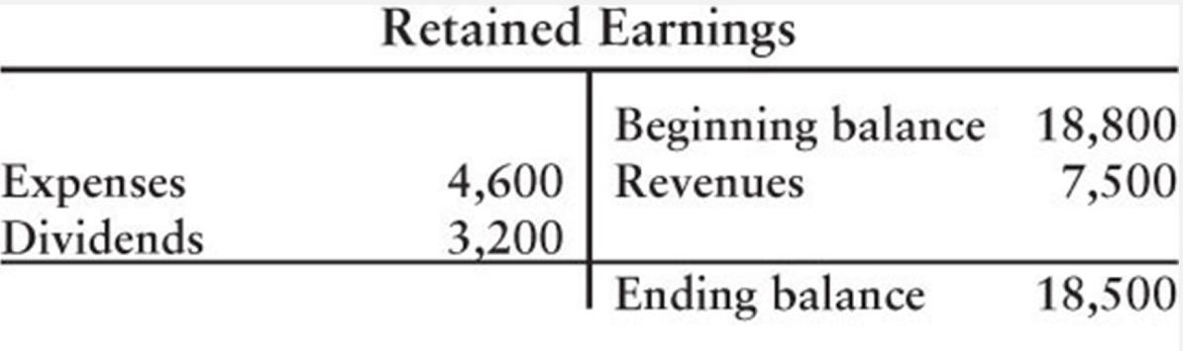

The following video is another great explanation of the closing entries: https://www.youtube.com/watch?v=oCJEW4T2xuk

Highlight #2: Accounting Ratios
Accounting Ratios are a quick way to measure the health of a business using the information provided to us in the financial statements. Ratios include net working capital, current ratio, and debt ratio.

The Net Working Capital ratio measures a company’s ability to pay off current debts with the current assets on hand (another word for this concept is operating liquidity).
Net Working Capital = Total Current Assets - Total Current Liability
Example:
Given $20,000 in cash, $10,000 in accounts receivable, $5,000 in notes payable, and $6,000 in accounts payable, what is the net working capital?
Answer: $19,000. You add up the current assets (cash + AR = $30,000) to find the total current assets. You also add up the current liabilities (NP + AP = $11,000) to find the total current liabilities. Then subtract total current liabilities from the total current assets ($30,000 - $11,000).

The Current Ratio is another way of measuring operating liquidity. Companies generally want a ratio falling between 1.2-1.5
Current Ratio = Total Current Assets / Total Current Liabilities
Example:
Given $20,000 in cash, $10,000 in accounts receivable, $5,000 in notes payable, and $6,000 in accounts payable, what is the current ratio?
Answer: 2.73. You add up the current assets (cash + AR = $30,000) to find the total current assets. You also add up the current liabilities (NP + AP = $11,000) to find the total current liabilities. Then divide the total current liabilities from the total current assets ($30,000 / $11,000).

The Debt Ratio reveals what portion of the company’s assets are funded by debt. Also measures the ability to pay current and long-term debts. A lower debt ratio is better.
Debt Ratio = Total Liabilities / Total Assets
Example:
Given $20,000 in cash, $10,000 in accounts receivable, $25,000 in long-term assets, $5,000 in notes payable, $15,000 in long-term liabilities, and $6,000 in accounts payable, what is the debt ratio?
Answer: 0.47. You add up the assets (cash + AR + LT assets = $55,000) to find the total assets. You also add up the liabilities (NP + LT liabilities + AP = $26,000) to find the total liabilities. Then divide the total assets from the total liabilities ($26,000 / $55,000).

See the following videos about the accounting ratios for additional help:
Current Ratio: https://www.youtube.com/watch?v=sWWnsvuQ3kk&feature=youtu.be
Net Working Capital: https://www.youtube.com/watch?v=EovKfDwRt9Q&feature=youtu.be
Debt Ratio: https://www.youtube.com/watch?v=zeZOjxK-908&feature=youtu.be

Check Your Learning:
- Closing Entries:
Assume Baylor Had the Following Balances in the following accounts at the end of the year. Perform the closing entries (Hint: follow the three steps from above)
Cash: $100,000
Accounts Payable: $50,000
Service Revenue: $80,000
Rent Exp $50,000
Utilities Exp: $4,000
Dividends $5,000
Retained Earnings $5,000

- 1st JE:
DR: Service Revenue $80,000
CR: _____________ $______
- 2nd JE:
DR: Retained Earnings $54,000 (Expenses)
CR: Utilities Exp $4,000
CR: _______ Exp $______

- 3rd JE:
DR: Retained Earnings: $5,000
CR: _______ $______

- Accounting Ratios:
Given the following amounts calculate the company’s net working capital, current ratio, and debt ratio:
Current assets $50,000
Current liabilities $25,000
Long-term assets $70,000
Long-term liabilities $35,000
Total revenues $30,000
Total expenses $20,000

Net Working Capital = ______
Current Ratio = ______
Debt Ratio = ______

Things You May Struggle With:
- Knowing what is an asset, liability, or stockholder’s equity is critical to perform journal entries and the ratios.
- Don’t mix up the current ratio and debt ratio. The current ratio deals with the current assets and current liabilities. It also has current liabilities as the numerator of the equation.
- Don’t forget the three steps to closing a temporary account.

Thanks for checking out these weekly resources!
Don’t forget to check out our website for group tutoring times, video tutorials, and lots of other
resources: www.baylor.edu/tutoring ! Answers to check your learning questions are below!

Answers to Check Your Learning:

1i. Retained Earnings, $80,000
1ii. Rent, $50,000
1iii. Dividends, $5,000

2. Net Working Capital = $25,000
Current Ratio = 2
Debt Ratio = 0.5

