Week 6
ACC 2303 – Financial Accounting
Hello and welcome to the weekly resources for ACC 2303!
This week is Week 6 of classes, and typically in this week of the semester, your professors are covering these topics below. If you do not see the topics your particular section of class is learning this week, please take a look at other weekly resources listed on our website for additional topics throughout the semester.
We also invite you to take a look at the group tutoring chart on our website to see if this course has a group tutoring session offered this semester.
If you have any questions about these study guides, group tutoring sessions, private 30-minute tutoring appointments, the Baylor Tutoring YouTube channel or any tutoring services we offer, please visit our website www.baylor.edu/tutoring or call our drop-in center during open business hours, M-Th 9am-8pm on class days, at 254-710-4135.

Keywords: Fraud, Fraud Triangle, Opportunity, Motive, Rationalization, Internal Controls, and Sarbanes-Oxley (SOX)

Topic of the Week: Fraud

Highlight #1: Fraud
Fraud is any intentional misrepresentation of facts. This usually causes some sort of injury or damage to another party.
Types of accounting fraud:
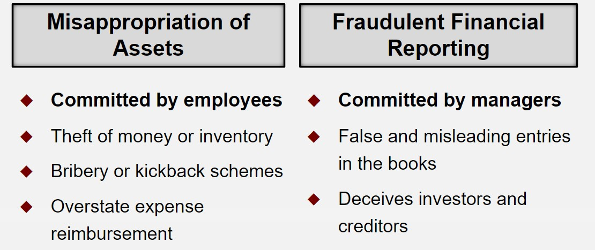

Highlight #2: Fraud Triangle
The Fraud Triangle illustrates the three most common reasons people commit fraud in organizations.
The three reasons are:
- Opportunity to Commit Fraud: Management leaves holes in company procedure allowing people to commit fraud
- Rationalization: People give a justification for why committing fraud is ok (For example: “It’s just one time and I am short on cash”
- Motive: External and internal factors push people towards fraud (e.g. underpaid staff)

The Fraud Triangle:
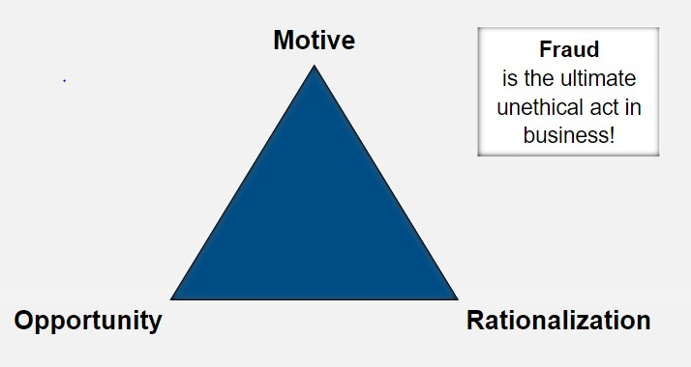

The following video give a more in-depth description of the fraud triangle: https://www.youtube.com/watch?v=4nZtnU4fUFs&feature=youtu.be

Highlight #3: Internal Controls
Internal controls are policies and procedures that minimize the pull of the elements in the fraud triangle to try and prevent fraud. Internal Controls are implemented by managers and the Board of Directors.
Internal Controls minimize fraud by preventing, detecting, and correcting errors and fraud internal controls also hone in on making an operation more effective.
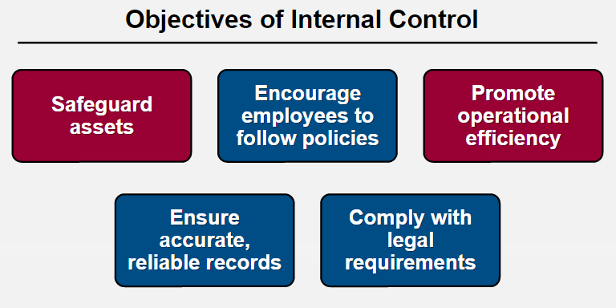

What is Sarbanes-Oxley (SOX)? This legislation requires that publicly traded companies keep robust internal control systems and report on the internal controls to external entities. This legislation also created the Public Company Accounting Oversight Board (PCAOB).

Some internal control procedures are:
Smart Hiring Practices: Conduct background checks, quality training, and competitive salaries
Separation of Duties: Keep custody, approval, and recording separate (Remember this through the word CAR!)
Comparison and Compliance Monitoring: Conduct routine audits
Adequate Records: use prenumbered documents, record details of transactions, use hard copy or have an electronic copy of business data
Limited Access: limit access to assets through lock boxes, passwords, encryption, etc.
Proper Approvals: Require management, purchasing, receiving, and credit departments to approve certain actions

Check Your Learning:
- What are the two types of accounting fraud?
  - Fraudulent Financial Reporting and Internal Differences
  - Fraudulent Communication and Misappropriation of Assets
  - Misappropriation of Assets and Fraudulent Financial Reporting
  - Fraudulent Communication and Internal Differences

- Which of the following is not an internal control procedure?
  - Having multiple duties
  - Having smart hiring practices
  - Adequate Records
  - Limited Access
  - Comparison and Compliance Monitoring

- True or False: The three points of the fraud triangle is opportunity, motive, and rationalization.
  - True
  - False

Things You May Struggle With:
- Knowing the different characteristics of the two types of fraud.
- Knowing the internal controls and examples of each

Thanks for checking out these weekly resources!
Don’t forget to check out our website for group tutoring times, video tutorials, and lots of other
resources: www.baylor.edu/tutoring ! Answers to check your learning questions are below!

Answers to Check Your Learning:

      - C
      - A
      - A

