Week 7
ACC 2303 – Financial Accounting
Hello and welcome to the weekly resources for ACC 2303!
This week is Week 7 of classes, and typically in this week of the semester, your professors are covering these topics below. If you do not see the topics your particular section of class is learning this week, please take a look at other weekly resources listed on our website for additional topics throughout the semester.
We also invite you to take a look at the group tutoring chart on our website to see if this course has a group tutoring session offered this semester.
If you have any questions about these study guides, group tutoring sessions, private 30-minute tutoring appointments, the Baylor Tutoring YouTube channel or any tutoring services we offer, please visit our website www.baylor.edu/tutoring or call our drop-in center during open business hours, M-Th 9am-8pm on class days, at 254-710-4135.

Keywords: Bank reconciliations, Bank side, Book side, Outstanding checks, NSF checks, EFTs

Topic of the Week: Bank Reconciliations

Highlight #1: Bank Reconciliations
Bank reconciliations help explain the differences between an organization’s accounting records and bank records that exist due to timing. Gives us an accurate picture of the cash account’s real balance. There are two sides that we need to reconcile: the bank side and the book side.
The elements of each side are illustrated in the following chart: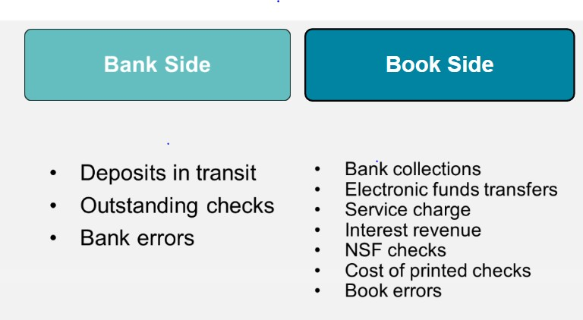
On the bank side:
Add:
- Deposits in Transit
- Bank errors
Subtract (overstatement):
- Outstanding Checks
- Bank errors (understatement)

On the book side:
Add:
- Bank Collections
- EFT Receipts (Revenue)
- Interest Revenue
- Book error
Subtract (overstatement):
- Service charge
- NSF Checks
- EFT payments
- Book error (understatement)
It is important to note that the ending balances of the bank and books should equal each other.

The following video gives a good example of working out a bank reconciliation: https://www.youtube.com/watch?v=9LfnlMz2Aic#action=share

Highlight #2: Vocabulary of Bank Reconciliation
Outstanding Checks are check payments that have been recorded by the issuing entity, but which have not yet cleared its bank account as a deduction from its cash balance.
Deposits in Transit are checks that have been written but are in the process of being deposited.
EFT stands for electronic funds transfer
NSF checks are nonsufficient funds checks (e.g. bank balance is not enough to carry out payment or receipt)

Highlight #3: Bank Reconciliation Example Problem

The following information will be used to reconcile the bank and books:
Bank statement balance $10,200
Balance per books 9,559
Debit memo (NSF check) 259
Debit memo (service charge) 25
Credit memo (Note collection, including $18 interest) 1,818
Deposit in transit, 8/31 4,434
Deposit in transit, 8/1, cleared 8/2 2,000 Outstanding checks 8/31 3,550
Check #102, a payment of $223, was recorded correctly on the books; appears on the bank statement as $232

Using the information above reconcile the Bank and Books:

On the bank side:
Starting Balance: $10,200

Add:
Deposits in Transit: $4,434 (Note: Deposit in transit on 8/1 cleared on 8/2 so we ignore it)
Bank Error: $9

Subtract:
Outstanding Checks: $3550

Adjusted Balance: $11,093
On the book side:
Starting Balance: $9,559

Add:
Note Collection: $1,818

Subtract:
Service Charge: $25
NSF Check $ 259

Adjusted Balance: $11,093

Check Your Learning:
- Which of the following is not recorded on the bank side?
  - Bank Collections
  - Deposits in transit
  - Bank Errors
  - Outstanding Checks
  - All answer choices could be recorded on the bank side

- Which of the following is not recorded on the book side?
  - EFTs
  - Interest Revenue
  - NSF checks
  - Book Error
  - All answer choices could be recorded on the bank side
- True or False: Deposits in Transit are check payments that have been recorded by the issuing entity, but which have not yet cleared its bank account as a deduction from its cash balance.
  - True
  - False

Things You May Struggle With:
- Confusing what is recorded on the bank with what’s recorded on the book side.
- Also, confusing whether you should add or subtract the value.
- Also, make sure to read carefully and not mix up bank error with book error and vice versa.

Thanks for checking out these weekly resources!
Don’t forget to check out our website for group tutoring times, video tutorials, and lots of other
resources: www.baylor.edu/tutoring ! Answers to check your learning questions are below!

Answers to Check Your Learning:

      - A
      - E
      - B

