Week 8
ACC 2303 – Financial Accounting
Hello and welcome to the weekly resources for ACC 2303!
This week is Week 3 of classes, and typically in this week of the semester, your professors are covering these topics below. If you do not see the topics your particular section of class is learning this week, please take a look at other weekly resources listed on our website for additional topics throughout the semester.
We also invite you to take a look at the group tutoring chart on our website to see if this course has a group tutoring session offered this semester.
If you have any questions about these study guides, group tutoring sessions, private 30-minute tutoring appointments, the Baylor Tutoring YouTube channel or any tutoring services we offer, please visit our website www.baylor.edu/tutoring or call our drop-in center during open business hours, M-Th 9am-8pm on class days, at 254-710-4135.

Keywords: Direct Write-off Method, Bad debt expense, Accounts Receivables, Allowance Method, Allowance for Doubtful Accounts, Contra-Asset, Net Realizable Value, Aging of Receivables Method, Percent of Sales Method

Topic of the Week: Direct Write-Offs and the Allowance Method for Doubtful Accounts

Highlight #1: Uncollectible Account Receivables
The accounts receivable account represents a promise made by an external company to pay for goods or services at a later date. Sometimes companies will not be able to pay these debts that they owe. As such, will need to adjust our records to reflect the delinquency of these accounts. To do this, we use either the Direct Write-Off method or the Allowance method.

Highlight #2: Direct Write-Off Method
The Direct Write-off Method waits until an account is determined to be uncollectible before it “writes off” the account. To “write off” an account under this method we use the following journal entry:
DR: Bad Debt Expense (for the amount uncollectible)
CR: Accounts Receivable (for the amount uncollectible)

This journal entry gets rid of the expectation that we will receive these funds and records this amount as an expense.

Example:
Bob the Tomato received notice that Larry the Cucumber would not be able to pay what he owed to Bob (totaling: $5,000,000). What would the JE be under the Direct method?
Answer:
DR: Bad Debt Expense: $5,000,000
CR: Allowance for Doubtful Accounts: $5,000,000
Write off method has a few shortcomings. This method violates the expense matching principle by not recognizing an expense in the same period that revenue is earned. In doing so, this method violates GAAP and overstates assets and net income. This method will only be used in tax reporting.

Highlight #2: Allowance Method
The Allowance Method is a two-step process that estimates bad debt expense at the end of the current accounting period and uses adjusting entries to write off customer accounts that become uncollectible. To do this, we use the following journal entries:
Estimate Journal Entry:
DR: Bad Debt Expense
CR: Allowance for Doubtful Accounts

Write-Off Entry:
DR: Allowance for Doubtful Accounts
CR: Accounts Receivable
Note that the allowance method is required by GAAP and introduces a new account: Allowance for Doubtful Accounts.
Allowance for Doubtful Accounts (AFDA) is an account that reflects the amount of accounts receivable that we do not expect to collect. It is a contra- asset meaning that this account is listed as an account on the balance sheet that reduces an asset. The AFDA account specifically reduces the accounts receivable account and yields a helpful equation for determining how much of accounts receivable a company expects to collect. This amount is called the Net Realizable Value. The NRV equation is as follows:
NRV= Accounts Receivable – AFDA

Highlight #3: Methods Used to Estimate Bad Debt Expense and Allowance for Doubtful Accounts
The Percent of Sales Method uses a predetermined percentage of sales to estimate BDE (bad debt expense) and AFDA. This is also called the income statement approach.
The following example gives a good example of the percent of sales method in action: https://www.youtube.com/watch?v=ZjkbN4ofu10&feature=youtu.be
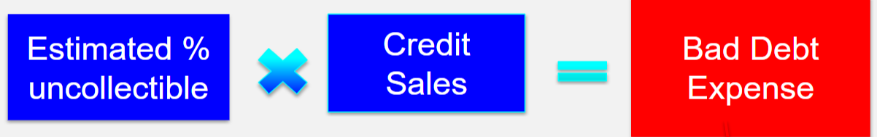
Example (Using Percent of Sales Method):
Texas INC uses the Percentage of sales method to adjust the allowance for uncollectible accounts at the end of the period. On December 31, the balance of accounts receivable is $220,000 and the allowance for uncollectible accounts has a credit balance of $3,200 (before adjustment). Total sales for the year are $800,000 of which $200,000 are cash sales.
If Texas estimates bad debts to be 2% of credit sales, bad debt expense would be?
Answer: $12,000 (($800,000-$200,000) *.02)
What would the balance of the AFDA account be after the adjustment for Bad Debt Expenses?
Answer: $15,200 (3200+12000)

The Aging of Receivables Method assigns a percentage estimate based on the age (how long the customer AR account has been outstanding) of the accounts receivable. This is illustrated in the following graphic.
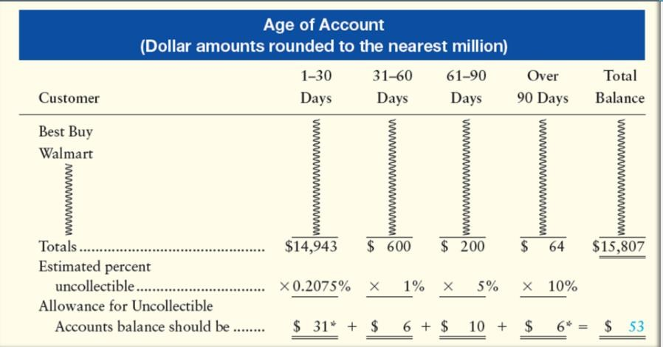
The following video gives a good example of the aging of receivables method in action: https://www.youtube.com/watch?v=1wq1rw46NTc&feature=youtu.be

Check Your Learning:
- Bruiser received notice that Bevo would not be able to pay what he owed to Bruiser (totaling: $300,000). What would the JE be under the Direct method?
  - DR: Bad Debt Expense $30,000
CR: Allowance for Doubtful Accounts $30,000
  - DR: Allowance for Doubtful Accounts $30,000
CR: Bad Debt Expense $30,000
  - DR: Bad Debt Expense $300,000
CR: Allowance for Doubtful Accounts $300,000
  - DR: Allowance for Doubtful Accounts $300,000
CR: Bad Debt Expense $300,000

Use the following information for the next two questions:
Baylor Landscaping uses the Percentage of sales method to adjust the allowance for uncollectible accounts at the end of the period. On June 30, the balance of accounts receivable is $150,000 and the allowance for uncollectible accounts has a credit balance of $4,500 (before adjustment). Total sales for the year are $500,000 of which $50,000 are cash sales.
- If Baylor Landscaping estimates bad debts to be 4% of credit sales, bad debt expense would be?
  - $18,000
  - $14,000
  - $180,000
  - $4,000
- What would the balance of the AFDA account be after the adjustment for Bad Debt Expenses?
  - $54,500
  - $22,500
  - $13,500
  - $18,500

Things You May Struggle With:
- Mixing up the order of when to debt or credit BDE or AFDA.
- Remembering to take out cash sales from total sales in order to find credit sales
- Remembering to add back the beginning balance of the account

Thanks for checking out these weekly resources!
Don’t forget to check out our website for group tutoring times, video tutorials, and lots of other
resources: www.baylor.edu/tutoring ! Answers to check your learning questions are below!

Answers to Check Your Learning:

      - C
      - A (($500,000-$50,000) *.04)
      - B ($18,000+$4,500)

