Week 9
ACC 2303 – Financial Accounting
Hello and welcome to the weekly resources for ACC 2303!
This week is Week 9 of classes, and typically in this week of the semester, your professors are covering these topics below. If you do not see the topics your particular section of class is learning this week, please take a look at other weekly resources listed on our website for additional topics throughout the semester.
We also invite you to take a look at the group tutoring chart on our website to see if this course has a group tutoring session offered this semester.
If you have any questions about these study guides, group tutoring sessions, private 30-minute tutoring appointments, the Baylor Tutoring YouTube channel or any tutoring services we offer, please visit our website www.baylor.edu/tutoring or call our drop-in center during open business hours, M-Th 9am-8pm on class days, at 254-710-4135.

Keywords: Cost of Goods Sold Account (COGS), specific unit, average cost, LIFO, and FIFO

Topic of the Week: Inventory

Highlight #1: Accounting for Inventory

How do we account for Inventory? Before inventory has been sold, we recognize the cost of these items as inventory (asset account) on the balance sheet. After the inventory is sold, it is viewed as an expense and is ushered under the Cost of Goods Sold Account (COGS). Or in other words, “what did we spend to make this inventory ‘happen’?”
The following graphic illustrates this:

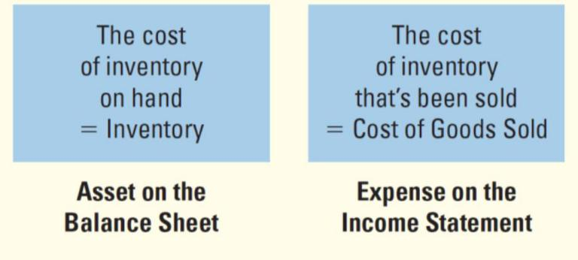

We will use the following formulas to calculate the balance of inventory accounts and cost of goods sold accounts:
Inventory:

COGS:

These are the following journal entries when accounting for inventory:

Purchase of Inventory:

DR: Inventory $$$$
CR: Accounts Payable/Cash $$$$

Sale of Inventory:

Sale Portion
DR: Accounts Receivable/Cash $$$$
CR: Sales Revenue $$$$

Expense Portion
DR: COGS (Expense) $$$$
CR: Inventory $$$$

Highlight #2: valuing purchases and COGS using T-Accounts or Formulas

The following image gives the formula for purchases:
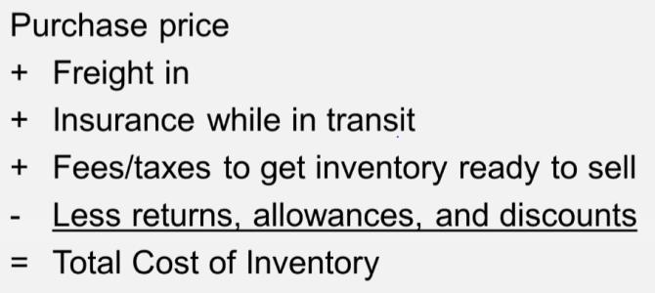

The following image gives the t-account formula for COGS:
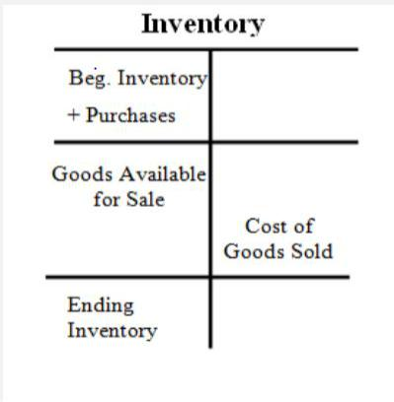

Highlight #3: Inventory Costing Methods

There are four major inventory costing methods in accounting: specific unit, average cost, LIFO, and FIFO. These methods are used to calculate ending inventory and COGS for a given period.

Using Specific Unit, inventory and COGS are valued using the costs of a particular unit. Typically used for companies with unique, highly-specialized, low volume goods.

Average Cost uses the average price of inventory over the period is used to calculate ending inventory and COGS. Best for uniform and high-volume goods.

Average Cost= Cost of Goods available (see example for how to calculate this)/Number of goods

FIFO (First in First out) expenses the earliest-purchased goods first during transactions. This means that the latest-purchased goods will be leftover at the end of the period.

LIFO (Last in First Out) expenses the latest-purchased goods first during transactions. This means that the earliest-purchased goods will be leftover at the end of the period.

Note: Under each method increasing or decreasing costs impact COGS and Ending Inventory based on the method used. The following charts illustrate this:

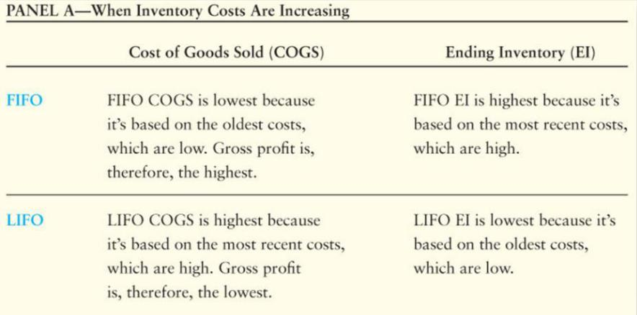

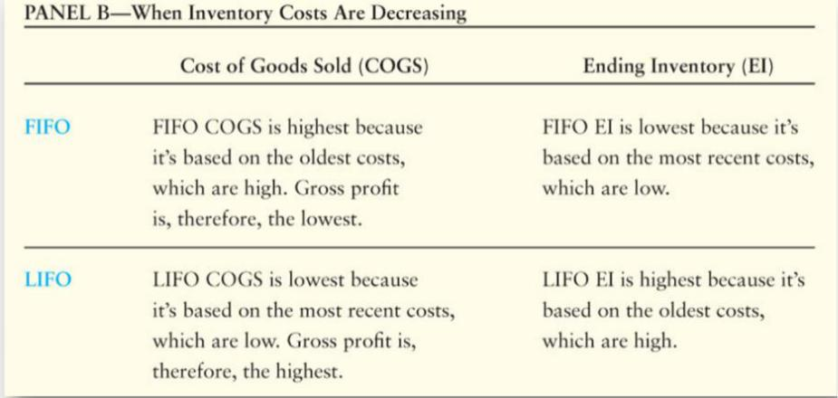

Example:
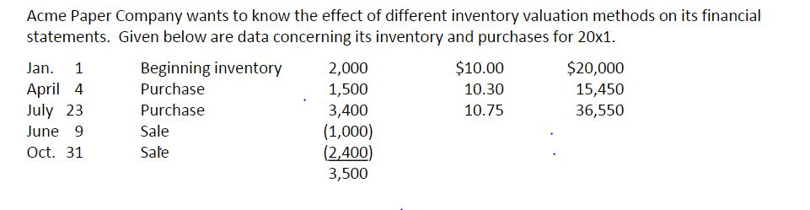

Using the information above, below are the ending inventories and COGS use each different method.

FIFO Method:
COGS: (1000*$10) + (1000*$10) + (1400*$10.30) = $34,420
Ending Inventory: (100*$10.30) + (3400*$10.75) = $37,580

LIFO Method
COGS: (1000*$10.75) + (2400*$10.75) = $36,550
Ending Inventory: (2000*$10) + (500*$10.30) + (1000*$10.75) = $35900

AVG Method:
AVG Cost: ((2000*$10) + (1500*$10.30) + (3400*$10.75))/6900 = 10.43
COGS: 3400*$10.43 = $35,462
Ending Inventory: 3500*$10.43 = $36,505

The following videos provide additional examples for each method:
FIFO: https://www.youtube.com/watch?v=Wa83L8TvoaM&feature=youtu.be
LIFO: https://www.youtube.com/watch?v=zLAvpS6o25E&feature=youtu.be
AVG Cost: https://www.youtube.com/watch?v=qAWVVw-dC5A&feature=youtu.be

Check Your Learning:
- What is the correct journal entry format for the purchasing of inventory? (Hint: it is the first journal entry to do when accounting for inventory)
  - DR: Accounts Receivable/Cash $$$$
CR: Sales Revenue $$$$
  - DR: COGS (Expense) $$$$
CR: Inventory $$$$
  - DR: Inventory $$$$
CR: Accounts Payable/Cash $$$$
  - DR: Accounts Payable/Cash $$$$
CR: Inventory $$$$
- Baylor Landscaping purchased inventory on the following dates:
June 6 500 units at $10
June 12 1,000 units at $15
June 27 200 units at $20
What is the average unit cost of inventory?
  - $15.00
  - $14.12
  - $14.50
  - $13.82

- Baylor Cupcakes purchased inventory on the following dates:
August 1 150 units $1,040
August 9 200 units $1,560
August 12 200 units $1,680
August 23 150 units $1,320
$5,600
A count of merchandise inventory on August 31 reveals that there are 210 units on hand. Using the FIFO method, the amount allocated to ending inventory for August is:
  - $1,824
  - $1,426
  - $1,912
  - $1,745

Things You May Struggle With:
- Knowing what purchase amount to use from the given information. Know the definitions of each method, so it’s easier to know what inventory cost to use.
- Knowing what to add verse subtract when valuing a purchase. Remember the image from above that shows what to add or subtract.

Thanks for checking out these weekly resources!
Don’t forget to check out our website for group tutoring times, video tutorials, and lots of other
resources: www.baylor.edu/tutoring ! Answers to check your learning questions are below!

Answers to Check Your Learning:

      - C
      - B ((500*10) + (1000*15) + (200*20)) / (500 + 1000 + 200)
      - A ((1680/200)*60) + 1320

