**ECO 2306 – Principles of Microeconomics**

Week 13

**Hello and Welcome to the weekly resources for ECO 2306 – Principles of Microeconomics!**

**This week is Week 13 of class, and typically in this week of the semester, your professors are covering these topics below.**  If you do not see the topics your particular section of class is learning this week, please take a look at other weekly resources listed on our website for additional topics throughout of the semester.

We also invite you to **look at the group tutoring chart on our website to see if this course has a group tutoring session offered this semester**.

If you have any questions about these study guides, group tutoring sessions, private 30 minute tutoring appointments, the Baylor Tutoring YouTube channel or any tutoring services we offer, please visit our website [www.baylor.edu/tutoring](http://www.baylor.edu/tutoring) or call our drop in center during open business hours. M-Th 9am-8pm on class days 254-710-4135.

Our main resource is going to be Principles of Microeconomics by N. Gregory Mankiw.

**Topic of the week**

**The Costs of Production**

**Keywords:** total revenue, total cost, profit, explicit costs, implicit costs, economic profit, accounting profit, production function, marginal product, diminishing marginal product, fixed costs, variable costs, average total cost, average fixed cost, average variable cost, marginal cost, efficient scale, economies of scale, diseconomies of scale, constant returns to scale.

**Concepts:**

So far we discussed producer surplus and firm revenue. We also discussed the supply curve and how it responds to the market price. We can learn where the supply curve comes from by analyzing costs.

**What are costs?**

Every form of production requires some input and produces some output. **Total revenue** is the amount a firm receives for the sale of its output. **Total cost** is the market value of the inputs a firm uses in production. **Profit** is the firm’s total revenue minus its total cost. A firm’s objective is to maximize its profits.

A firm’s cost of production includes two main categories. **Explicit costs** areinput costs that require an outlay of money by the firm like pay to workers, capital, and land. **Implicit costs** are input costs that do not require an outlay of money by the firm and include all the opportunity costs of what the firm could be doing with its time or money. Implicit costs are ignored by accountants.

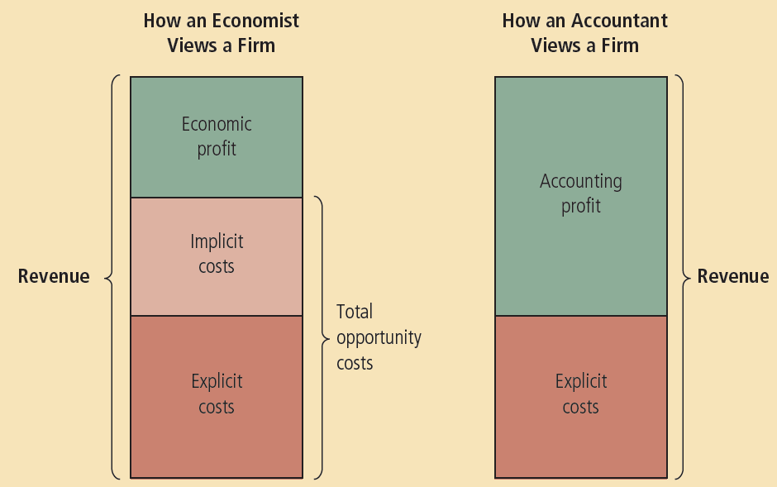

Figure 1 Economists vs Accountants (source: Cengage learning)

The cost of capital is an opportunity cost; a firm could invest its start-up capital in stocks and earn an interest on it, or simply save it for the future. The difference between what economists measure and what accountants measure leads us to two definitions for profit. **Economic profit** is total revenue minus total cost, which includes both explicit and implicit costs. **Accounting profit** is total revenue minus total explicit cost.

**Production and Costs**

**Production function** shows the relationship between the quantity of inputs to make a good and the quantity of output of that good. The production function gets flatter as production rises. The production function is defined by costs of production. A firm has two forms of costs to worry about: **Fixed costs** are costs that do not vary with the quantity of output produced (renting a store), and **variable costs** are costs that vary with the quantity of output produced (hourly wages). **Total cost** is the sum of fixed costs and variable costs.

**Average fixed cost (AFC)** is the fixed cost divided by the quantity of output. It decreases with production, because you spend the same amount of money to get a higher amount of output. For example, you pay the same rent for your store regardless of how many items you sell. **Average variable cost (AVC)** is the variable cost divided by the quantity of output. It usually increases linearly with production, because each extra unit produced has its own extra variable cost.

**Total-cost curve** shows the relationship between quantity produced and total costs. It gets steeper as the amount produced rises. Our analysis deals with average and marginal costs. **Average cost** is the amount it takes to produce one unit of output. **Marginal cost (MC)** is the amount it takes to increase the output by one unit.

The **law of diminishing returns** generally states that for an increase in effort, you get a smaller increase in outcome. For example, your final grade might be 80% after 5 hours of studying, but 10 hours of studying will not get you 160%, but may get you up to 95%. This law leads us to **diminishing marginal product** which is the property whereby the marginal product of an input declines as the quantity of the input increases.



Figure 2 Different cost curves of a firm (source: Mankiw)

Diminishing marginal product explains why the total cost curve gets steeper as production increases. The firm keeps spending more and more on inputs, but gets smaller and smaller increases in output. The **average total cost curve (ATC)** reflects the decreasing quality of the average fixed cost and the increasing quality of the average variable cost. Therefore, the average total cost curve is U shaped.



Figure 3 Production function vs Total cost curve (source: Mankiw)

**Efficient scale** is the quantity of output that minimizes the average total cost (ATC). When MC<ATC, average total cost is falling and the firm should increase production to achieve efficient scale. When MC>ATC, average total cost is rising and the firm should decrease its production to achieve efficient scale. The marginal cost curve crosses the average total cost curve at its minimum point.

**Costs in the Short Run and in the Long Run**

Many decisions of the firm are fixed in the short run, but variable in the long run. For example, you can’t get out of your lease or negotiate a lower rent in the short run. Also, many of the machines that you purchase for your business are fixed in the short run. Therefore, firms have greater flexibility in the long run. Long run cost curves differ from short run cost curves and tend to be flatter. Why? Because as we discussed before, elasticity is higher in the long run. Short run costs are equal to or greater than long run costs.



Figure 4 short run vs long run (source: Mankiw)

**Economies of scale** is the property whereby long-run average total cost falls as the quantity of output increases. This is true for firms that can hire a large number of workers and let them *specialize* in different areas. Auto manufacturers have economies of scale. **Diseconomies of scale** is the property whereby long-run average total cost rises as the quantity of output increases. This is true for firms that can’t easily expand due to management complications. Local mom and pop stores are good examples. **Constant returns to scale** the property whereby long-run average total cost stays the same as the quantity of output changes. Constant returns is quite rare. A good example is a carwash. If the carwash uses twice as much water and labor to wash two cars instead of one, it will double its costs and double its output.

**What you might struggle with**

This chapter has a lot of new terms that might be confusing. Here’s a table to help you remember them.



Figure 5 summary of costs (source: Mankiw)

**Check your learning**

1. Buffy is thinking about opening an amulet store. She estimates that it would cost $350,000 per year to rent the location and buy the merchandise. In addition, she would have to quit her $80,000 per year job as a vampire hunter.

a. Define *opportunity cost*.

b. What is Buffy’s opportunity cost of running the store for a year?

c. Buffy thinks she can sell $400,000 worth of amulets in a year. What would her accountant consider the store’s profit?

d. Should Buffy open the store? Explain.

e. How much revenue would the store need to generate for Buffy to earn positive economic profit? (source: Mankiw)

2. A commercial fisherman notices the following relationship between hours spent fishing and the quantity of fish caught:



a. What is the marginal product of each hour spent fishing?

b. Use these data to graph the fisherman’s production function. Explain its shape.

c. The fisherman has a fixed cost of $10 (his pole). The opportunity cost of his time is $5 per hour. Graph the fisherman’s total-cost curve. Explain its shape. (source: Mankiw)

3. You are the chief financial officer for a firm that sells gaming consoles. Your firm has the following average-total-cost schedule:



Your current level of production is 600 consoles, all of which have been sold. Someone calls, desperate to buy one of your consoles. The caller offers you $550 for it. Should you accept the offer? Why or why not? (source: Mankiw)

4. Consider the following table of long-run total costs for three different firms: (Source: Mankiw)



Does each of these firms experience economies of scale or diseconomies of scale?

**Answers**

These are my answers. You should be able to come up with your own arguments that may or may not differ from mine.

1. a. everything she could do instead of running a store.

b. $80,000 from job and whatever interest she can make from putting $350,000 elsewhere.

c. $50,000

d. no. the $50,000 profit is less than what she could make from her job.

e. at least $430,000

2. a. 12-2h, h being the hour

b. it’s flattening which shows diminishing returns

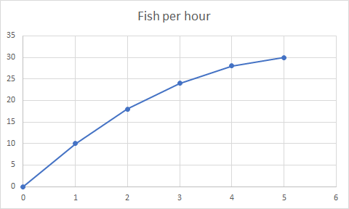

c. it gets steeper as production increases

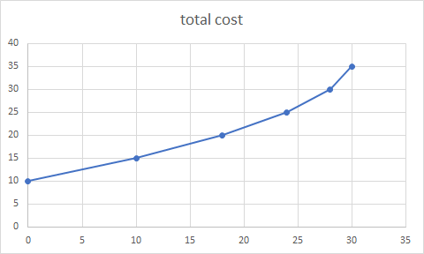

3. It will cost $901 to produce that new console. You should not do it.

è C = 901

4. average total cost = (total cost)/quantity

Firm A has economies of scale, as average total cost decreases with quantity

Firm B has diseconomies of scale, as average total cost increases with quantity

Firm C has diseconomies of scale, as average total cost increases with quantity

Thanks for checking out these weekly resources!

Don’t forget to check out our website for group tutoring times, video tutorials and lots of other resources: [www.baylor.edu/tutoring](http://www.baylor.edu/tutoring) ! Answers to check your learning questions are below!