**ECO 2306 – Principles of Microeconomics**

Week 14

**Hello and Welcome to the weekly resources for ECO 2306 – Principles of Microeconomics!**

**This week is Week 14 of class, and typically in this week of the semester, your professors are covering these topics below.**  If you do not see the topics your particular section of class is learning this week, please take a look at other weekly resources listed on our website for additional topics throughout of the semester.

We also invite you to **look at the group tutoring chart on our website to see if this course has a group tutoring session offered this semester**.

If you have any questions about these study guides, group tutoring sessions, private 30 minute tutoring appointments, the Baylor Tutoring YouTube channel or any tutoring services we offer, please visit our website [www.baylor.edu/tutoring](http://www.baylor.edu/tutoring) or call our drop in center during open business hours. M-Th 9am-8pm on class days 254-710-4135.

Our main resource is going to be Principles of Microeconomics by N. Gregory Mankiw.

**Topic of the week**

**The Costs of Production**

**Keywords:** competitive market, average revenue, marginal revenue, sunk cost.

**Concepts:**

Now that we have studied firms in isolation, we need to understand their behavior in the market. In this chapter, we examine the behavior of competitive firms, such as your local gas station.

**What is a Competitive Market?**

A **competitive market** or a *perfectly competitive market* is a market in which there are many buyers and sellers and the goods offered by various sellers are largely the same. Also, firms can freely enter or exit the market. Therefore, the actions of each individual has a negligible effect on the market. In this situation, buyers and sellers are price takers.



Figure 1 Total, Average, Marginal Revenue for a competitive firm (source: Mankiw)

We know that revenue is quantity times price. Given that a competitive firm is a price taker, the only thing it can choose is the quantity of production. **Average revenue** is the total revenue divided by the quantity sold. **Marginal revenue (MR)** is the change in total revenue from an additional unit sold. For competitive firms, average revenue and marginal revenue are both equal to the market price. For example, consider the gas station in the figure 1.

**Profit Maximization**

In order to maximize profits, a competitive firm has to produce a quantity where total revenue minus total cost is greatest. The firm has to compare its marginal revenue and marginal cost. If MR>MC, the firm has to increase its production. If MR<MC, the firm has to decrease production. When MR=MC, the firm has maximized profit. You can see this trend in figure 2.



Figure 2 Profit Maximization (source: Mankiw)

The marginal cost curve that we learned about in the previous section determines the quantity that a firm is willing to produce at any price, so it is the same as the supply curve.



Figure 3 profit maximization for a competitive firm (source: Mankiw)

Based on what we discussed, firms have to make decisions in the short run and the long run. In the short run, the firm’s total revenue has to be greater than its variable costs. If TR<VC, the firm decides to shut down. Therefore, a competitive firm’s short-run supply curve is that portion of its marginal cost curve that lies above average variable cost.

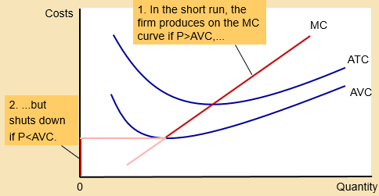

Figure 4 Short run supply curve (source: Cengage learning)

Every firm has a **sunk cost** which is a cost that has already been committed and cannot be recovered. In the short run, the firm ignores its sunk cost in order to make decisions. For example, a restaurant decides to stay open on a slow day if revenue can cover wages, not the price of furniture or kitchen equipment.

In the long run, the firm has to decide whether or not it should stay in the market. The firm’s decision is to leave the market if total revenue less than total cost, and enter the market if TR > TC. Therefore, a competitive firm’s long run supply curve is that portion of its marginal cost curve that lies above average total cost.



Figure 5 Long run supply curve (source: Mankiw)

We can measure the firm’s profit using our graphs. If P>ATC, then profit exists. We know that profit is the difference between total revenue and total cost, which is equal to (P-ATC)ˣQ. If P<ATC, then the firm makes negative profit, or loss. We can see these outcomes on the following graphs.

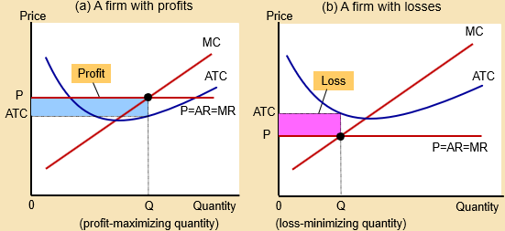

Figure 6 graphic representation of profit (source: Cengage learning)

**The Supply Curve in a Competitive Market**

In the short run, the total number of firms is fixed. Each firms supplies a quantity such that P=MC. Market supply is the total quantity supplied by all firms. We know that when P>AVC, supply curve is the firms marginal cost curve. So we put all MC curves together and get the market’s supply curve.



Figure 7 short run market supply with 1000 identical firms (source: Mankiw)



Figure 8 long run market supply (source: Mankiw)

In the long run, firms can enter and exit the market. When P>ATC and there is a profit to make, firms enter the market. When P<ATC and we have losses, firms exit the market. This process of entering and leaving the market ends when P=ATC and firms make zero economic profit. At this point MC=ATC, so we have efficient scale.

What happens when there is an increase in demand? In the short run, when the demand curve shifts to the right, the new equilibrium price and quantity will be higher. Since P>ATC, there will be positive economic profit. In the long run, more firms enter the market to benefit from these new profits, and that brings the equilibrium price back down and firm profits will equal zero again.



Figure 9 a shift in demand (source: Mankiw)

**What you might struggle with**

An important note here is competitive firms stay in the market even though economic profit is zero. This is because economic cost includes all opportunity costs, so all these firms that are making zero economic profits, make a good deal of positive accounting profits.

**Check your learning**

1. 1. Many small boats are made of fiberglass and a resin derived from crude oil. Suppose that the price of oil rises.

a. Using diagrams, show what happens to the cost curves of an individual boat-making firm and to the market supply curve.

b. What happens to the profits of boat makers in the short run? What happens to the number of boat makers in the long run? (source: Mankiw)

2. Bob’s lawn-mowing service is a profit-maximizing, competitive firm. Bob mows lawns for $27 each. His total cost each day is $280, of which $30 is a fixed cost. He mows 10 lawns a day. What can you say about Bob’s short-run decision regarding shutdown and his long-run decision regarding exit? (source: Mankiw)

3. Consider total cost and total revenue given in the following table:



a. Calculate profit for each quantity. How much should the firm produce to maximize profit?

b. Calculate marginal revenue and marginal cost for each quantity. Graph them. At what quantity do these curves cross? How does this relate to your answer to part (a)?

c. Can you tell whether this firm is in a competitive industry? If so, can you tell whether the industry is in a long-run equilibrium? (source: Mankiw)

4. Suppose the book-printing industry is competitive and begins in a long-run equilibrium.

a. Draw a diagram showing the average total cost, marginal cost, marginal revenue, and supply curve of the typical firm in the industry.

b. Hi-Tech Printing Company invents a new process that sharply reduces the cost of printing books. What happens to Hi-Tech’s profits and to the price of books in the short run when Hi-Tech’s patent prevents other firms from using the new technology?

c. What happens in the long run when the patent expires and other firms are free to use the technology? (source: Mankiw)

5. A firm in a competitive market receives $500 in total revenue and has marginal revenue of $10. What is the average revenue, and how many units were sold? (source: Mankiw)

6. An industry currently has 100 firms, each of which has fixed cost of $16 and average variable cost as follows:



a. Compute a firm’s marginal cost and average total cost for each quantity from 1 to 6.

b. The equilibrium price is currently $10. How much does each firm produce? What is the total quantity supplied in the market?

c. In the long run, firms can enter and exit the market, and all entrants have the same costs as above. As this market makes the transition to its long-run equilibrium, will the price rise or fall? Will the quantity demanded rise or fall? Will the quantity supplied by each firm rise or fall? Explain your answers.

d. Graph the long-run supply curve for this market, with specific numbers on the axes as relevant. (source: Mankiw)

**Answers**

These are my answers. You should be able to come up with your own arguments that may or may not differ from mine.

1. a. a competitive firm’s short-run supply curve is that portion of its marginal cost curve that lies above average variable cost. A change in the price of oil leads to a change in AVC. In the figure below, we go from ACV 1 to AVC 2, supply curve is now that portion of MC which is above AVC2. At the same price, there is more supply and at the same quantity, there is a higher price.

b. lower profit in the short run, long run depends on demand.

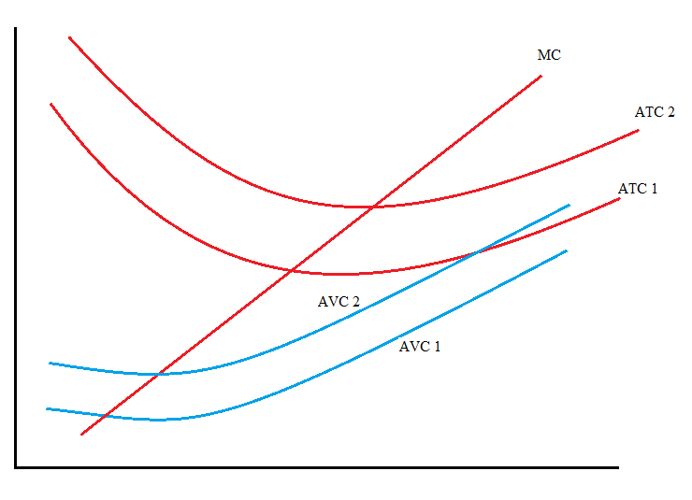

2. his variable cost is $250, in the short run his revenue is $270 which is more than his variable cost, so he should work. In the long run, he is taking a loss, so he should exit.

3. a. either 5 or 6

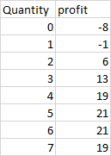

b. they cross at 6. 6 is the point where marginal cost exceeds marginal revenue, so there should be no more production.

c. marginal revenue is flat, so the firm is a price taker, which happens in a competitive market. There is an equilibrium in the market, which is why the price is fixed.

4. a. supply curve is the green portion of the MC curve below.

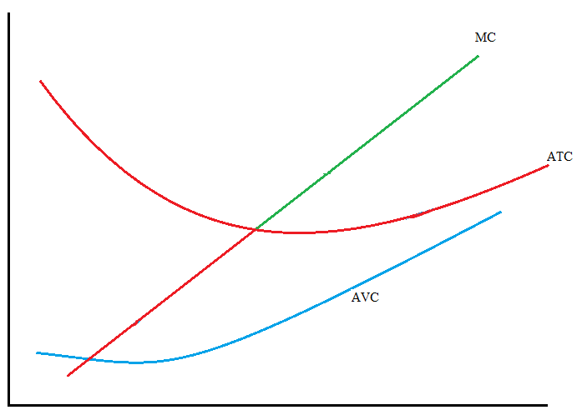

b. the firm’s average total cost is down, but since other firms don’t have the technology, prices don’t change, so the firms profits increase.

c. In the long run, other firms adopt the technology and bring the market price down.

5. we have equilibrium, so AR=MR=P. so the price is $10, the firm has sold 50 units, the averagle revenue is $10.

6. a. (formulas are in figures 1 & 2)

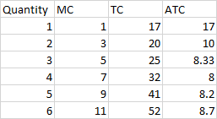

b. P=ATC, so the firm produces 2 units, makes $20 in revenue, makes zero profit. Market supplies 200 units.

c. it is possible to bring the average total cost down to 8, so more firms are going to enter the market until the equilibrium price reaches $8, at which point each firm will supply 4 units and the whole market will supply 400 units. The price is lower, so unless the demand is perfectly inelastic, it’s going to increase.

d. this graph is for one firm. For the entire market, multiply these number by 100.

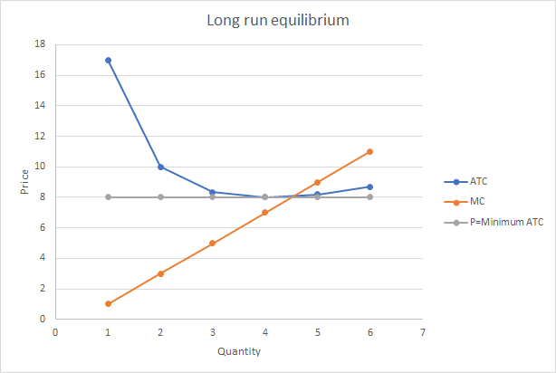

Thanks for checking out these weekly resources!

Don’t forget to check out our website for group tutoring times, video tutorials and lots of other resources: [www.baylor.edu/tutoring](http://www.baylor.edu/tutoring) ! Answers to check your learning questions are below!