**ECO 2306 – Principles of Microeconomics**

Week 15

**Hello and Welcome to the weekly resources for ECO 2306 – Principles of Microeconomics!**

**This week is Week 15 of class, and typically in this week of the semester, your professors are covering these topics below.**  If you do not see the topics your particular section of class is learning this week, please take a look at other weekly resources listed on our website for additional topics throughout of the semester.

We also invite you to **look at the group tutoring chart on our website to see if this course has a group tutoring session offered this semester**.

If you have any questions about these study guides, group tutoring sessions, private 30 minute tutoring appointments, the Baylor Tutoring YouTube channel or any tutoring services we offer, please visit our website [www.baylor.edu/tutoring](http://www.baylor.edu/tutoring) or call our drop in center during open business hours. M-Th 9am-8pm on class days 254-710-4135.

Our main resource is going to be Principles of Microeconomics by N. Gregory Mankiw.

**Topic of the week**

**Monopoly**

**Keywords:** monopoly, natural monopoly, price discrimination.

**Concepts:**

Many companies operate in a different way than what we discussed in the previous chapter. For example, there is no competitive market out there for Microsoft Windows. Such a company is known as a monopoly and operates in a unique way that we learn about in this chapter.

**Why Monopolies Arise**

A **monopoly** is a firm that is the sole seller of a product without any close substitutes. In general, we don’t like monopolies because they have all the power in a market. Absolute power corrupts absolutely and monopolies get corrupted very easily. Many economists believe preventing or dissolving monopolies is a role for the government.

The main cause if a monopoly is *barriers to entry:* A monopoly remains the only seller in its market because other firms cannot enter the market and compete with it. There are three main barriers to entry. *Monopoly resources* are key production resources that are owned by a single firm, such as a cobalt mine in Congo. *Government regulation* can give a firm the exclusive right or contract to provide a good or serves, such as national oil companies in the middle east. *The production process* may give a single firm the ability to provide a good or service at a much lower price than any other firm; Google is a quasi-monopoly for this reason.

A **natural monopoly** is a type of monopoly that arises because a single firm can supply a good or service to an entire market at a lower cost than could two or more firms. This kind of monopoly usually has economies of scale and offers club goods (excludable but not rival in consumption). For example, if a town is relatively small, it would make sense for it to only have one movie theater.

**How Monopolies Make Production and Pricing Decisions**

A competitive firm is a price taker, one of many producers, and has a horizontal line (price) as its demand. A monopoly however, has no one to compete with. Therefore, monopoly is the price maker in a market and faces a downward sloping demand.

A monopoly’s total revenue is price times quantity sold. Average revenue is revenue per unit sold, or total revenue divided by quantity. Marginal revenue is the revenue per each additional unit of output. The change in total revenue when output is increased by 1 could be negative, because the monopoly has to adjust its price based on the demand curve. Output effect mean the increase in quantity increases total revenue. Price effect means the decrease in price leads to a decrease in revenue. If the price effect is stronger than the output effect, marginal revenue is going to be negative.

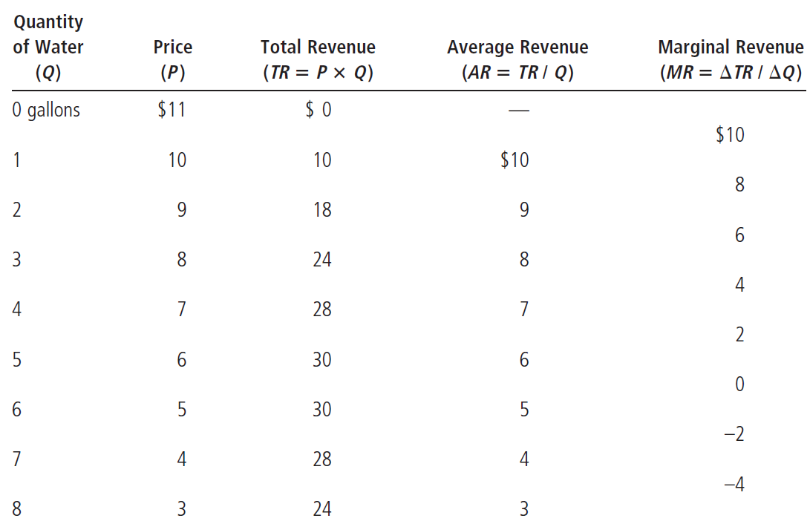

Figure 1 A Monopoly's revenue (source: Cengage learning)

To maximize profit, if MR>MC the firm should increase production, and if MR<MC it should decrease production. Therefore, the firm should produce a quantity at which MR=MC, this point is the intersection of the marginal revenue curve and the marginal cost curve. Price is determined by the demand curve. Note that a monopoly does not have a supply curve.



Figure 2 The monopolist's profit (source: Mankiw)

**The Welfare Cost of Monopolies**

We saw that a monopoly charges a higher price than a firm in a competitive market. Also, by looking at the demand curve and the marginal cost curve in figure 2, you can see that a monopoly supplies a smaller quantity than a group of competitive firms would. The socially efficient quantity is found where the demand curve and the marginal-cost curve intersect. The triangle that forms among this point and the cost and price of a monopoly is known as **the deadweight loss** **of monopoly.**

In other words, the monopoly’s profit is a cost to society as a whole. Having a monopoly increases producer surplus while decreasing consumer surplus (total economic welfare is not different from competition), and the society loses the desirable quantity of final products.



Figure 3 the inefficiency of monopoly (source: Mankiw)

A **patent** is a temporary monopoly granted by the government to a firm to exclusively produce a certain good. Even though a monopoly has some deadweight loss, a patent is not a bad thing, because the possibility market would not at all exist without the patent. So the total gain of a patent for the society is positive.

**Price Discrimination**

**Price discrimination** is the business practice of selling the same good at different prices to different customers. It’s a rational strategy for a monopoly to increase profit. A business that has some pricing power in the market and has a way to separate its customers is in a position to price discriminate. Price discrimination breaks down the overall demand into smaller sections.

For example, a musician can charge a very high price for front row seats at a concert. Wealthier people have a less steep (less price sensitive) demand curve and buy these expensive tickets. Also, there is usually a discounted price for seniors and students who have very steep price curves. This way, the business can maximize its earnings and reduce the amount of deadweight loss.



Figure 4 Welfare with and without price discrimination (source: Mankiw)

Price discrimination is a way to get every last dollar out of consumers. A firm with perfect price discrimination charges each customer differently (exactly his or her willingness to pay), gets the entire surplus (consumer surplus will be zero), and has no deadweight loss. Airlines, movie theaters, universities, and stores with different coupons and promotions are examples of price discriminating firms.

**Public Policy toward Monopolies**

Since monopolies do not allocate resources efficiently, government interference is necessary to bring efficiency back to the market. **Antitrust laws** are a group of statutes aimed at curbing monopoly power. Sherman Antitrust Act of 1890 and Clayton Antitrust Act of 1914 are examples of these laws that provide the government with the power to prevent or break up monopolies and ensure competition and economic freedom.

The government prevents the formation of monopolies by restricting *horizontal mergers,* which are mergers between companies who compete in the same area. For example, Pepsi and Coke or AT&T and Verizon would probably never be allowed to merge, since such a merger would create one very powerful company that has too much control over the market.

The government can also break up companies that are too powerful and have all the control in the market. For example, the Standard Oil company was broken up in 1911 into many smaller oil companies that compete against each other today. As a result, petrochemical products are cheaper and more plentiful.

**Regulation** is another method of dealing with monopolies. Especially in the case of natural monopolies, the government can interfere and regulate the behavior of monopolists. This is usually accomplished by dictating a set price. One problem that can arise is the regulators might set the price at marginal cost, which is below the monopolists average total cost and leads to a loss.



Figure 5 Marginal cost pricing for a natural monopoly (source: Mankiw)

Another policy is **public ownership**. This policy is popular in many European countries where the government owns utility companies. In the US, the government runs the Postal Service. Economists usually prefer private to public ownership of natural monopolies. Private companies have an incentive to lower costs and increase their benefits. Also, if a private company does bad, the owner would fire the manager and these private owners are the ones who lose. When public owners do a bad job, it’s the voters and taxpayers that lose.

Another policy toward monopolies is simply doing nothing. To understand this policy, ask yourself a simple question: what’s worse, market failure or political failure? There have been many cases where government-run monopolies have delivered worse results than private monopolies. In these cases, the best course of action for the government is to do nothing.

**What you might struggle with**

Here’s a cheat sheet to help you compare monopoly and competition.



Figure 6 Competition vs Monopoly (source: Mankiw)

**Check your learning**

1. A publisher faces the following demand schedule for the next novel from one of its popular authors:

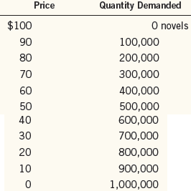

The author is paid $2 million to write the book, and the marginal cost of publishing the book is a constant $10 per book.

a. Compute total revenue, total cost, and profit at each quantity. What quantity would a profit-maximizing publisher choose? What price would it charge?

b. Compute marginal revenue. How does marginal revenue compare to the price? Explain.

c. Graph the marginal-revenue, marginal-cost, and demand curves. At what quantity do the marginal-revenue and marginal-cost curves cross? What does this signify?

d. In your graph, shade in the deadweight loss. Explain in words what this means.

e. If the author were paid $3 million instead of $2 million to write the book, how would this affect the publisher’s decision regarding what price to charge? Explain.

f. Suppose the publisher was not profit-maximizing but was instead concerned with maximizing economic efficiency. What price would it charge for the book? How much profit would it make at this price? (source: Mankiw)

2. A small town is served by many competing supermarkets, which have the same constant marginal costs.

a. Using a diagram of the market for groceries, show the consumer surplus, producer surplus, and total surplus.

b. Now suppose that the independent supermarkets combine into one chain. Using a new diagram, show the new consumer surplus, producer surplus, and total surplus. Relative to the competitive market, what is the transfer from consumers to producers? What is the deadweight loss? (source: Mankiw)

3. A company is considering building a bridge across a river. The bridge would cost $2 million to build and nothing to maintain. The following table shows the company’s anticipated demand over the lifetime of the bridge:



a. If the company were to build the bridge, what would be its profit-maximizing price? Would that level of output be efficient? Why or why not?

b. If the company is interested in maximizing profit, should it build the bridge? What would be its profit or loss?

c. If the government were to build the bridge, what price should it charge?

d. Should the government build the bridge? Explain. (source: Mankiw)

4. You live in a town with 300 adults and 200 children, and you are thinking about putting on a play to entertain your neighbors and make some money. A play has a fixed cost of $2,000, but selling an extra ticket has zero marginal cost. Here are the demand schedules for your two types of customer:



a. To maximize profit, what price would you charge for an adult ticket? For a child’s ticket? How much profit do you make?

b. The city council passes a law prohibiting you from charging different prices to different customers. What price do you set for a ticket now? How much profit do you make?

c. Who is worse off because of the law prohibiting price discrimination? Who is better off?

d. If the fixed cost of the play were $2,500 rather than $2,000, how would your answers to parts (a), (b), and (c) change?

**Answers**

These are my answers. You should be able to come up with your own arguments that may or may not differ from mine.

1. a. A profit maximizing firm will sell 300,000 copies at $70 each.

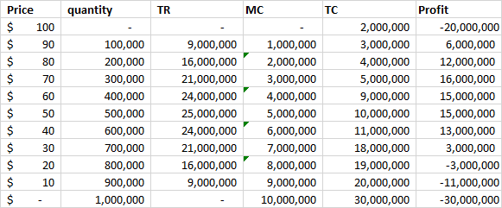

b. marginal revenue decreases with price.

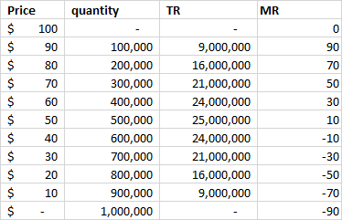

c. They cross at about $55 (I tweaked the numbers to make the chart look good), which shows the monopoly can sell at a higher price and make a profit.

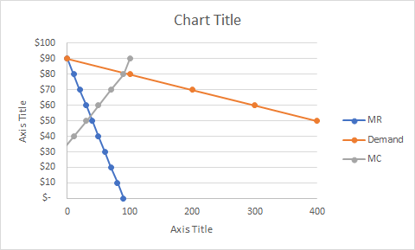

d.

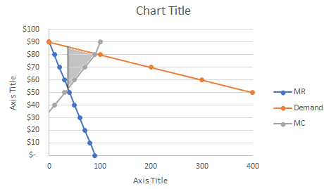

e. The profit maximizing point would be the same, so the price is still $70. Total profit would be $1,000,000 lower.

f. It would behave like a competitive firm and would make zero profits. Price would be about $25.

2. a. Total surplus = Consumer surplus + Producer surplus

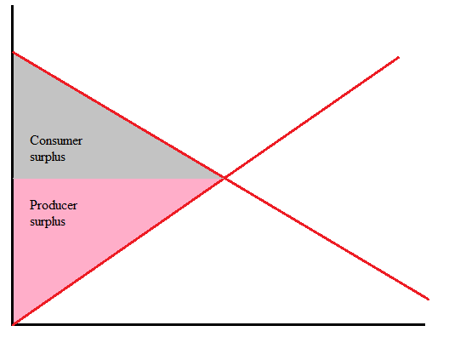

b. Consumer surplus and producer surplus are both smaller. The deadweight loss is the amount of total surplus that could have been achieved under competition due to the lower price.

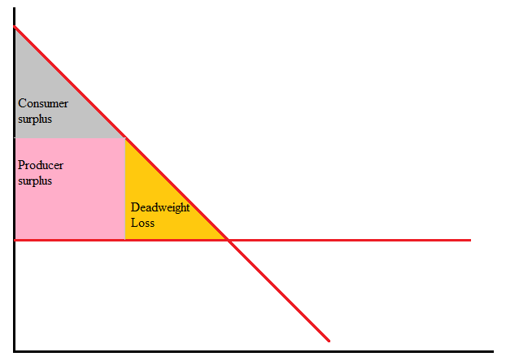

3. a. $4 per crossing, 400 crossings, 1.6 million dollars in total revenue. It’s not efficient because it does not address the entire demand.

b. It should not build the bridge, there will be a 400-thousand-dollar loss.

c. It’s a matter of opinion. The government builds the bridge with your money, so you decide.

d. Yes, because the private sector will not.

4. a. $7 per adult, $4 per child, $2900 in total revenue, $900 in profits.

b. $7 for everyone. You make $100 in profits.

c. Consumers are worse off because 200 children missed out on the play, seller is worse off due to making smaller profits.

d. (a) Would be the same, but profit would be $400. (b) is the same, but there is a loss of $400 (which means you don’t put on the play to begin with, unless you hate money). (c) is the same.

Thanks for checking out these weekly resources!

Don’t forget to check out our website for group tutoring times, video tutorials and lots of other resources: [www.baylor.edu/tutoring](http://www.baylor.edu/tutoring) ! Answers to check your learning questions are below!