**ECO 2306 – Principles of Microeconomics**

Week 3

**Hello and Welcome to the weekly resources for ECO 2306 – Principles of Microeconomics!**

**This week is Week 3 of class, and typically in this week of the semester, your professors are covering these topics below.**  If you do not see the topics your particular section of class is learning this week, please take a look at other weekly resources listed on our website for additional topics throughout of the semester.

We also invite you to **look at the group tutoring chart on our website to see if this course has a group tutoring session offered this semester**.

If you have any questions about these study guides, group tutoring sessions, private 30 minute tutoring appointments, the Baylor Tutoring YouTube channel or any tutoring services we offer, please visit our website [www.baylor.edu/tutoring](http://www.baylor.edu/tutoring) or call our drop in center during open business hours. M-Th 9am-8pm on class days 254-710-4135.

Our main resource is going to be Principles of Microeconomics by N. Gregory Mankiw.

**Topic of the week**

**Interdependence and the Gains from Trade**

**Keywords:** trade, absolute advantage, comparative advantage, imports, exports.

**Concepts:**

Are you alone in the world? Of course not! We all live withing a giant web of interconnected individuals, firms, and systems. Every day we benefit from the fruits of other people’s labor and in turn contribute to those around us in many ways. You are actually not aware of the many ways others influence your life. These connections form what we study this week.

**A Parable for the Modern Economy**

Imagine there are only two goods in the world: beef and potatoes. Ruby produces meat and Frank produces potatoes. Frank is free to live an independent life and eat nothing but the potatoes he grows. Ruby can do the same thing. But I’m sure at some point Frank gets tired of potatoes. He could trade some of his potatoes for some of Ruby’s meat, and they both would be better off. This is the simplest explanation of the benefits of trade. However, what if Frank produces both meat and potatoes? 

Figure 1 PPF for two independent producers

Remember the production possibilities frontier? Let’s say Frank produces 1 ounce of potatoes in 15 minutes and 1 ounce of meat in 60 minutes. Ruby produces 1 ounce of potatoes in 10 minutes and 1 ounce of meat in 20 minutes. If they each work 8 hours a day, their production possibilities frontiers would look like figure 1. Notice that the frontier is linear (as opposed to the previous chapter where it was bowed out); this is because we’re assuming they use the same technology to produce each good and have a constant level of productivity.

They could divide their times and produce any amount on the frontier. You can see that Ruby is better at producing both goods and will have a higher total amount to consume. We can say Ruby has an **Absolute Advantage**, which means she can produce a good using fewer inputs than another producer or produce more for a given input. It is tempting to think Ruby should never trade with Frank. But there’s a catch.

Let’s assume they make a deal: Frank spends all of his time producing potatoes, so 32 ounces of potatoes per day. Ruby spends 4 hours producing meat and 4 hours producing potatoes, so 12 ounces of meat and 24 ounces of potatoes. Frank trades 15 ounces of his potatoes for 5 ounces of Ruby’s meat. Look at the table below. Can you see how they’ve both benefited from trade?



Figure 2 gains from trade for two producers

**Comparative Advantage and Specialization**

In order to better understand the reason for these gains, you need to learn about **Comparative Advantage.** A producer that can produce a good at a lower opportunity cost than another producer has comparative advantage. For Ruby, the opportunity cost of producing 1 ounce of potatoes is ½ ounce of meat, but for Frank it’s ¼ ounce of meat. Frank’s opportunity cost of producing potatoes is lower than Ruby’s, so we can say Frank has a comparative advantage over Ruby in producing potatoes.

Although it is possible for one person to have an absolute advantage in both goods, it is impossible for one person to have a comparative advantage in both goods. The opportunity cost of one good is the inverse of the opportunity cost of the other, so if a person’s opportunity cost of one good is relatively high, the opportunity cost of the other good must be relatively low. Comparative advantage reflects the relative opportunity cost. Trade can benefit everyone in society because it allows people to specialize in the activities in which they have a comparative advantage.

For both parties to gain from trade, the price at which they trade must lie between their opportunity costs. A mutually advantageous trade can be struck at a price between 2 and 4. In this price range, Ruby wants to sell meat to buy potatoes, and Frank wants to sell potatoes to buy meat.

**Application in real life**

LeBron James can mow his own lawn in 2 hours thanks to his strength. Katelyn, the girl who lives next door, can do the same job in 4 hours. LeBron has an absolute advantage here. But should he mow his own lawn? Well, in 2 hours, he could star in a commercial and earn $30,000. Katelyn could spend 4 hours working at McDonald’s and make $50. We can see that Katelyn has a comparative advantage in mowing the lawn, because her opportunity cost of doing so is much lower. As long as LeBron pays Katelyn more than $50 and less than $30,000, they are both better off.

Countries can achieve the same thing through trade. Goods produced abroad and sold domestically are called **imports**. Goods produced domestically and sold abroad are called **exports**. Imagine the US and Japan produce nothing but cars and food, and they are equally good at producing cars. However, the US has much more fertile land and can produce food much easier than Japan. This gives Japan a comparative advantage at producing cars. Through trading Japanese cars for American food, both countries will have more cars and more food.

We can say trade makes everyone better off by increasing the size of the economic pie. International trade is not a war zone in which some countries win and some others lose, but all countries end up more prosperous. However, some individuals will suffer losses from trade. In the above example, Japanese farmers and American auto workers will lose some jobs. We analyze this issue more in the future.

**What you might struggle with**

Most people mix up absolute advantage and comparative advantage. You should be able to see the difference in everyday examples. One way to better understand this is applying it to doing household chores. Try to see which family members have an absolute or comparative advantage in any given task. Can you reallocate tasks in your family in a way that increases total outcome?

**Check your learning**

1. If two parties trade based on comparative advantage and both gain, in what range must the price of the trade lie? (Source: Mankiw)

2. Why do economists oppose policies that restrict trade among nations? (Source: Mankiw)

3. Maria can read 20 pages of economics in an hour. She can also read 50 pages of sociology in an hour. She spends 5 hours per day studying.

a. Draw Maria’s production possibilities frontier for reading economics and sociology.

b. What is Maria’s opportunity cost of reading 100 pages of sociology? (source: Mankiw)

4. England and Scotland both produce scones and sweaters. Suppose that an English worker can produce 50 scones per hour or 1 sweater per hour. Suppose that a Scottish worker can produce 40 scones per hour or 2 sweaters per hour.

a. Which country has the absolute advantage in the production of each good? Which country has the comparative advantage?

b. If England and Scotland decide to trade, which commodity will Scotland export to England? Explain.

c. If a Scottish worker could produce only 1 sweater per hour, would Scotland still gain from trade? Would England still gain from trade? Explain. (source: Mankiw)

**Answers**

These are my answers. You should be able to come up with your own arguments that may or may not differ from mine.

1. Anywhere between their opportunity costs.

2. consumers in both nations will have lower prosperity.

3. a.

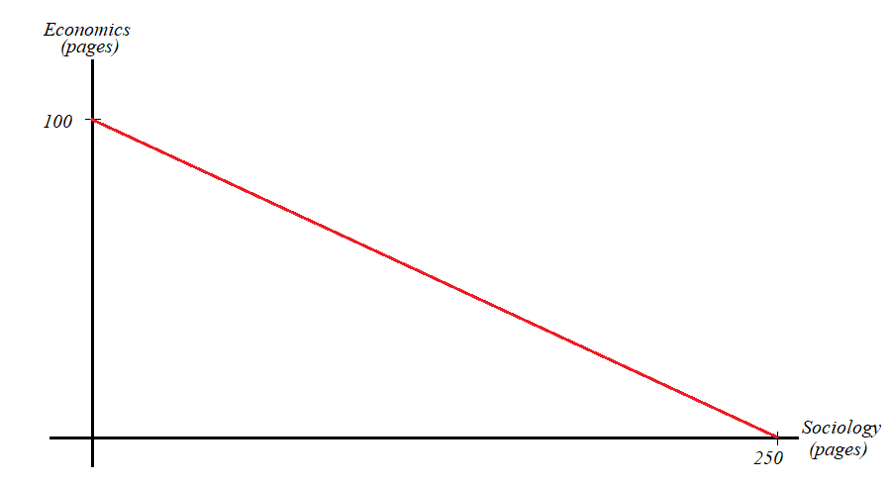

b. reading 40 pages of economics.

4. a. England has absolute advantage in scones and Scotland in sweaters.

The opportunity cost of producing 1 sweater for England is 50 scones.

The opportunity cost of producing 1 sweater for Scotland is 20 scones.

Scotland has comparative advantage in producing sweaters.

The opportunity cost of producing 1 scone for England is 1/50 sweaters.

The opportunity cost of producing 1 scone for Scotland is 1/20 sweaters.

England has comparative advantage in producing scones.

b. Sweaters. A country is better off exporting what it has a comparative advantage in producing.

c. Scotland will have the opportunity cost of 1/40 sweaters, which is still lower than England’s, so it would benefit from trade. Similarly, England is still better off producing 50 scones in an hour and importing sweaters from Scotland.

Thanks for checking out these weekly resources!

Don’t forget to check out our website for group tutoring times, video tutorials and lots of other resources: [www.baylor.edu/tutoring](http://www.baylor.edu/tutoring) ! Answers to check your learning questions are below!