**ECO 2306 – Principles of Microeconomics**

Week 5

**Hello and Welcome to the weekly resources for ECO 2306 – Principles of Microeconomics!**

**This week is Week 5 of class, and typically in this week of the semester, your professors are covering these topics below.**  If you do not see the topics your particular section of class is learning this week, please take a look at other weekly resources listed on our website for additional topics throughout of the semester.

We also invite you to **look at the group tutoring chart on our website to see if this course has a group tutoring session offered this semester**.

If you have any questions about these study guides, group tutoring sessions, private 30 minute tutoring appointments, the Baylor Tutoring YouTube channel or any tutoring services we offer, please visit our website [www.baylor.edu/tutoring](http://www.baylor.edu/tutoring) or call our drop in center during open business hours. M-Th 9am-8pm on class days 254-710-4135.

Our main resource is going to be Principles of Microeconomics by N. Gregory Mankiw.

**Topic of the week**

**Elasticity and Its Applications**

**Keywords:** elasticity, total revenue, price elasticity of demand, income elasticity of demand, cross-price elasticity of demand, price elasticity of supply.

**Concepts:**

So far, we have learned that buyers and sellers respond to market conditions. For example, a war in the middle east will increase the price of gas and that affects the market in the United States. In this chapter we explore the size of this effect. We want to know how much buyers and sellers respond to changes in market conditions. This concept is known as **elasticity** and has many applications in analyzing supply and demand.

**The elasticity of demand**

Our general understanding of demand says consumers will buy more of an item if it’s cheaper or they make more money. The **price elasticity of demand** measures how much the quantity demanded responds to a change in price. Demand for a good is said to be *elastic* if the quantity demanded responds substantially to changes in the price. Demand is said to be *inelastic* if the quantity demanded responds only slightly to changes in the price.

Elasticity determines the slope of our demand curve. Price elasticity of demand is important because businesses need to set their prices with respect to it. Also, government policies such as student loans or the minimum wage are affected by elasticity. **Elastic** demand means the quantity demanded responds substantially to changes in price. **Inelastic** demand means the quantity demanded responds only slightly to changes in price.

What determines the price elasticity of demand? If **close substitutes** are available, demand is more elastic. **Necessary goods** have inelastic demand while luxury goods have elastic demand. **Narrowly defined markets** have more elastic demand; food is a broad category and there are no substitutes for food, so demand for food is inelastic, but ice cream is a narrow category and the demand for ice cream is elastic. Also, demand is more elastic over longer **time horizons**.

In order to calculate the price elasticity of demand, we divide the percentage change in quantity demanded by the percentage change in price. Then we drop the minus sign, since we need an absolute value.



When price elasticity of demand is more than 1, we can say demand is elastic. When price elasticity of demand is less than 1, we can say demand is inelastic. When price elasticity of demand is 1, we can say demand has unit elasticity.

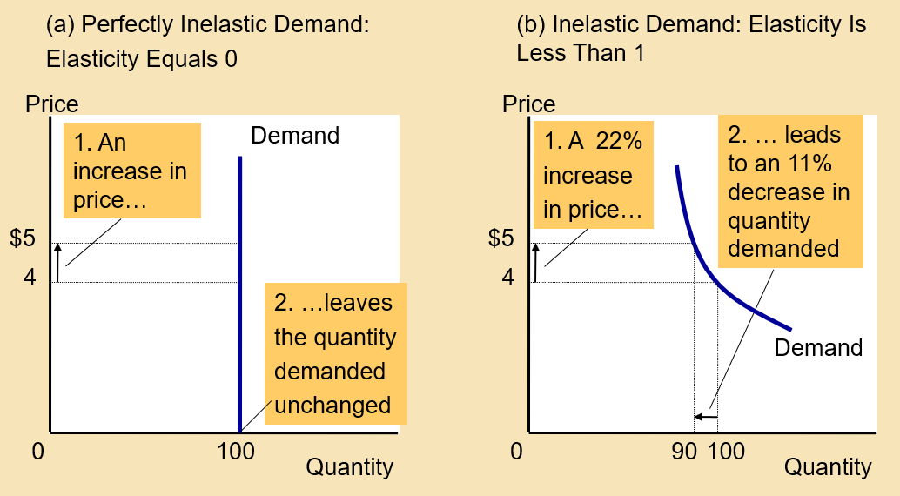

Figure 1 Inelastic Demand (source: Cengage learning)

Elasticity helps us understand the variety of demand curves. When price elasticity of demand is 0, demand is perfectly inelastic, and demand curve is vertical. When price elasticity of demand is infinity, demand is perfectly elastic, and demand curve is horizontal. The flatter the demand curve, the greater the price elasticity of demand.

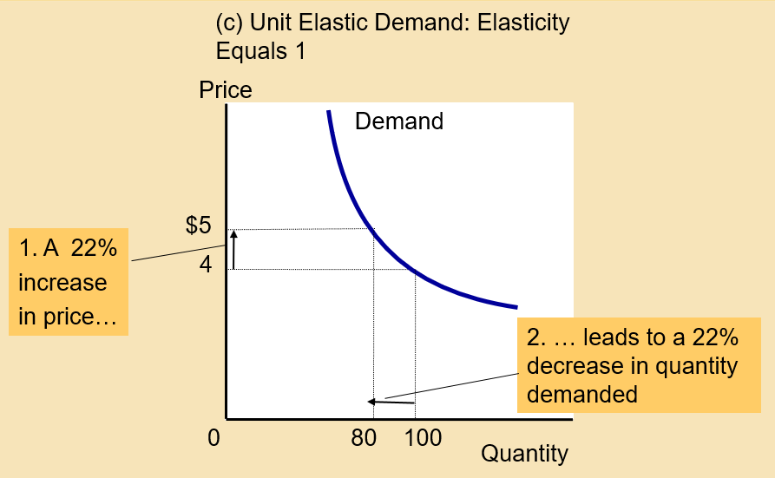

Figure 2 Demand has unit elasticity (source: Cengage learning)

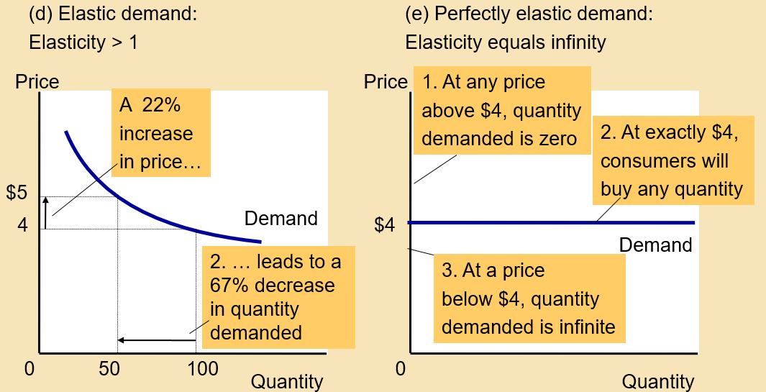

Figure 3 Elastic demand (source: Cengage learning)

­**Total revenue** isthe amount paid by buyers and received by sellers of a good, computed as the price of the good times the quantity sold (P ˣ Q). For a price increase, if demand is inelastic, total revenue increases, and if demand is elastic, total revenue decreases. When demand is unit elastic, total revenue does not change with price changes.

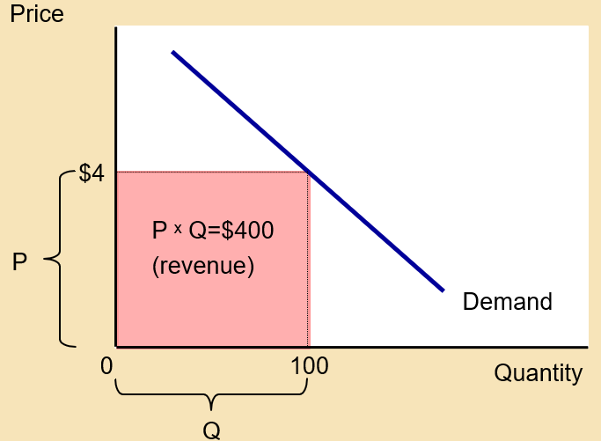

Figure 4 Total revenue (source: Cengage learning)

**Income elasticity of demand** is a measure of how much the quantity demanded of a good responds to a change in consumers’ income, computed as the percentage change in quantity demanded divided by the percentage change in income. **Normal goods** have a positive income elasticity of demand (more income = more demand). Necessities have elasticities of less than 1 and luxuries have elasticities of more than 1. **Inferior goods** have negative income elasticities of demand.

C**ross-price elasticity of demand** is a measure of how much the quantity demanded of one good responds to a change in the price of another good, computed as the percentage change in quantity demanded of the first good divided by the percentage change in price of the second good. Substitute goods have positive cross-price elasticity of demand and complements have negative elasticities.

**The Elasticity of Supply**

**Price elasticity of supply** is a measure of how much the quantity supplied of a good responds to a change in the price of that good, computed as the percentage change in quantity supplied divided by the percentage change in price. It depends on the flexibility of sellers to change their production quantities.

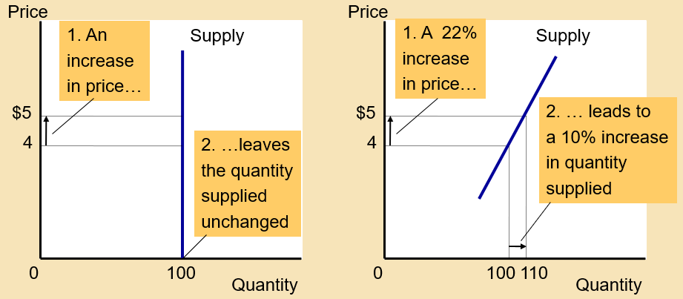

Figure 5 Inelastic supply (source: Cengage learning)

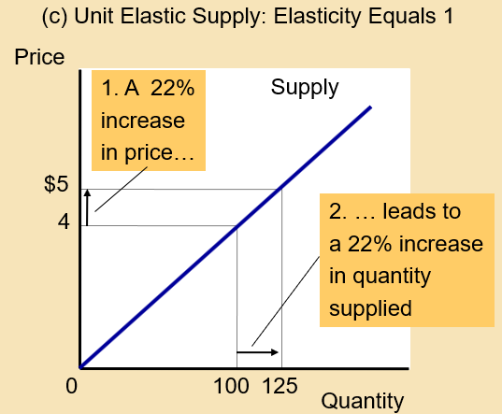

Figure 6 Unit elastic supply (source: Cengage learning)

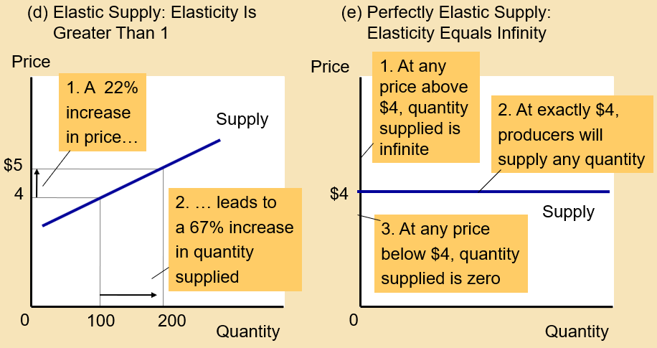

Figure 7 Elastic supply (source: Cengage learning)

**Elastic supply** (price elasticity > 1) means quantity responds substantially to changes in the price. Digital downloads and wireless networks have elastic supplies, which means it’s easy to sell a lot of them. **Inelastic supply** (price elasticity < 1) means quantity responds only slightly to changes in the price. Hand-made goods or houses have inelastic supplies, because it’s hard to sell a lot of them.

The price elasticity of supply can vary. Because firms often have a maximum capacity for production, the elasticity of supply may be very high at low levels of quantity supplied and very low at high levels of quantity supplied.



Figure 8 Varying price elasticity of supply (source: Mankiw)

**Application**

Imagine a new hybrid of wheat increases production per acre by 20%, so the supply curve shifts to the right. So the quantity increases and the price drops. Given that the demand for wheat (and other foodstuff) is inelastic, farmers make less money at the new equilibrium point. You may think farmers would not adopt the new technology, but they do. In a competitive market, farmers are price takers. This is a real-life example; in 1950, about 17% of the American labor force worked on farms, while today due to farming being less profitable, only about 2% do.



Figure 9 An increase in the supply of wheat

In 1973, OPEC decided to increase the price of oil to increase its revenues. Member countries successfully did this and the price of oil rose by 50% from 1973 to 1974. They did this again, and this time the price of oil doubled from 1979 to 1981. These shocks did not last long, and the prices steadily decreased after each jump. In 1990, the price of oil reached its 1970 level again.

This shows the difference between short-term and long-term elasticities. In the short term, demand for oil is very inelastic, because cars, household, and firms require energy like before. However, in the long-term people adjust; companies produce more efficient cars and people consume less energy. France even gave-up on oil and went nuclear. So long-term demand is much more elastic, and a decrease in supply does not increase prices by much.



Figure 10 Different effects of supply shifts (source: Mankiw)

**What you might struggle with**

If you have a hard time with elasticity, look at the goods you buy every day, and think about how your income, price of the goods, and price of other goods affect your decision to buy the goods. Estimate the elasticity of your demand with regards to some goods.

**Check your learning**

1. How did Covid-19 affect the demand for video games? What about the elasticity of demand?

2. For each of the following pairs of goods, which good would you expect to have more elastic demand and why?

a. required textbooks or mystery novels

b. Adele recordings or pop music recordings in general

c. subway rides during the next six months or subway rides during the next five years

d. root beer or water (source: Mankiw)

3. A price change causes the quantity demanded of a good to decrease by 30 percent, while the total revenue of that good increases by 15 percent. Is the demand curve elastic or inelastic? Explain (source: Mankiw)

4. You are the curator of a museum. The museum is running short of funds, so you would like to increase revenue. Should you increase or decrease the price of admission? Explain. (source: Mankiw)

5. Two drivers, Walt and Jessie, each drive up to a gas station. Before looking at the price, each places an order. Walt says, “I’d like 10 gallons of gas.” Jessie says, “I’d like $10 worth of gas.” What is each driver’s price elasticity of demand? (source: Mankiw)

**Answers**

These are my answers. You should be able to come up with your own arguments that may or may not differ from mine.

1. Increased the demand. Increased income elasticity of demand, because if you lose your job, video games become luxury goods. Decreased price elasticity of demand, because options that compete with video games (e.g., playgrounds) shut down.

2. a. novels (you don’t have to buy them), b. recordings in general (people want to listen to Adele, so they might pay more), c. in the long run, people are more likely to find alternative transportation methods, so demand in the next five years is more elastic, d. Water. It’s more readily available, so it would be harder to increase the price of water without losing demand.

3. Inelastic. The drop in demand is smaller than the increase in price, so total revenue goes up.

4. Depends on your visitors. If you mostly serve people who **have to** be there (art students and professors, journalists) you should increase the price, because their demand is inelastic. If you want to serve average people, you have to decrease your prices, because their demand is elastic.

5. Walt’s demand is inelastic, he has to get 10 gallons no matter the price. Jessie’s demand is elastic, she can spend $10, no matter how much gas she can get.

Thanks for checking out these weekly resources!

Don’t forget to check out our website for group tutoring times, video tutorials and lots of other resources: [www.baylor.edu/tutoring](http://www.baylor.edu/tutoring) ! Answers to check your learning questions are below!