**ECO 2306 – Principles of Microeconomics**

Week 6

**Hello and Welcome to the weekly resources for ECO 2306 – Principles of Microeconomics!**

**This week is Week 6 of class, and typically in this week of the semester, your professors are covering these topics below.**  If you do not see the topics your particular section of class is learning this week, please take a look at other weekly resources listed on our website for additional topics throughout of the semester.

We also invite you to **look at the group tutoring chart on our website to see if this course has a group tutoring session offered this semester**.

If you have any questions about these study guides, group tutoring sessions, private 30 minute tutoring appointments, the Baylor Tutoring YouTube channel or any tutoring services we offer, please visit our website [www.baylor.edu/tutoring](http://www.baylor.edu/tutoring) or call our drop in center during open business hours. M-Th 9am-8pm on class days 254-710-4135.

Our main resource is going to be Principles of Microeconomics by N. Gregory Mankiw.

**Topic of the week**

**Supply, Demand, and Government Policy**

**Keywords:** price floor, price ceiling, tax incidence.

**Concepts:**

So far, we made scientific arguments based on observations. Now, we are going to learn about the role of economists as policy advisers. We learn about the intended and unintended effects of policy. To get you started, we talk about price controls and taxes.

**Controls on Prices**

Some people believe the government should regulate market prices. A **price ceiling** is a legal **maximum** on the price at which a good can be sold. A **price floor** is a legal **minimum** on the price at which a good can be sold. In politics, consumer groups usually lobby for price ceilings and producers lobby for price floors.



Figure 1 Effects of price ceilings (source: Mankiw)

There are two possible consequences to a price ceiling. If the price ceiling above the market equilibrium price, it has no effect on the market and it’s called a non-binding constraint. When the price ceiling is below the market equilibrium price, producers will lose those customers who where willing to pay the equilibrium price. Now, they have to ration their scarce resources and cut back on supply. This price ceiling is binding and leads to a **shortage** of goods in the market.

In a similar way, a price floor below the equilibrium price is not binding and has no effect on the market. A price floor above the equilibrium price is binding. It will lower the demand and increase the supply, which leads to a **surplus**. In this situation, some sellers are unable to sell what they want. You can think of this surplus in terms of a lot of food that goes to waste.



Figure 2 effects of price floors (source: Mankiw)

One common example of a price ceiling is rent control, which is when the government defines a rent ceiling. In the short term, landlords can’t change the number of units they rent. Building, buying, or selling new units takes time. Also, the number of renters in a city does not quickly respond to the price of rent, because moving takes time. The **short-term** supply and demand of rental units is **inelastic**, so the resulting shortage is quite small. In the **long run**, supply and demand are more **elastic**. Landlords who don’t find rent fair invest in other businesses or move to other cities. Renters from other areas take advantage of the low rents and move into the city. This new regime of supply and demand leads to a much larger shortage of units to rent.



Figure 3 Rent control (source: Mankiw)

A common example of a price floor is the minimum wage, which is the lowest amount an employer can pay to hire labor. In the market for labor, workers supply the labor and firms demand it. If the minimum wage is above the market equilibrium, firms can’t afford to hire as many workers as they need, and there will be a lot of unemployment. Since the labor market is not perfectly competitive, the minimum wage is not binding for highly skilled and experienced workers.

How do economists evaluate price controls? In general, most economists are against price floors and ceilings, since markets to a good job at organizing economic activity. While economists understand the need for and value of helping people, they argue that price control is not the only way. Other ways include rent and wage subsidies.

**Taxes**

Governments collect many types of taxes to pay for public projects. To begin our study of taxation we first need to learn how taxes affect the market. **Tax incidence** is the manner in which the burden of a tax is shared among participants in a market (producers or customers). When taxes are levied on the sellers, the supply curve shifts to the left, because the cost of production is higher now. The new equilibrium point has a higher price and a lower quantity, so both the sellers and the buyers are worse off.



Figure 4 A tax on sellers

A tax levied on the buyers will lead to a lower demand for the good, because some buyers can no longer afford to buy it. This shift in the demand curve leads to a new equilibrium point with a lower price and lower quantity. The size of the market is smaller and both buyers and sellers are worse off. **Taxes levied on sellers and taxes levied on buyers are equivalent.** Sellers and buyers will share the tax burden regardless of where the tax is applied.



Figure 5 A tax on buyers

What if we consider elasticity? When supply is more elastic than demand, the sellers have a larger tax burden. When demand is more elastic than supply, the buyers have a larger tax burden. In other words, those without good alternatives end up paying more taxes.

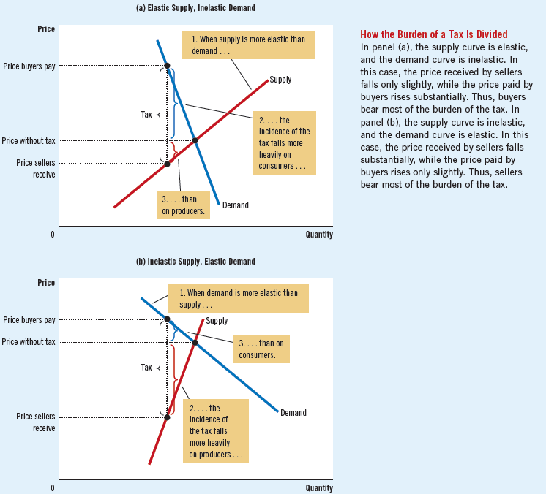

Figure 6 Taxes and elasticity

**What you might struggle with**

One important concept to understand as an economist is how regulations with good intentions can end up hurting the people they’re trying to help. Try to observe real-life situations where taxes and welfare have negative effects on the society.

**Check your learning**

1. Lovers of classical music persuade Congress to impose a price ceiling of $40 per concert ticket. As a result of this policy, do more or fewer people attend classical music concerts? Explain?

2. The government has decided that the free-market price of cheese is too low.

a. Suppose the government imposes a binding price floor in the cheese market. Draw a supply-and demand diagram to show the effect of this policy on the price of cheese and the quantity of cheese sold. Is there a shortage or surplus of cheese?

b. Producers of cheese complain that the price floor has reduced their total revenue. Is this possible? Explain

c. In response to cheese producers’ complaints, the government agrees to purchase all the surplus cheese at the price floor. Compared to the basic price floor, who benefits from this new policy? Who loses? (source: Mankiw)

3. A recent study found that the demand-and-supply schedules for Frisbees are as follows:



a. What are the equilibrium price and quantity of Frisbees?

b. Frisbee manufacturers persuade the government that Frisbee production improves scientists’ understanding of aerodynamics and is thus important for national security. A concerned Congress votes to impose a price floor $2 above the equilibrium price. What is the new market price? How many Frisbees are sold?

c. Irate college students march on Washington and demand a reduction in the price of Frisbees. An even more concerned Congress votes to repeal the price floor and impose a price ceiling $1 below the former price floor. What is the new market price? How many Frisbees are sold? (source: Mankiw)

4. Suppose the federal government requires beer drinkers to pay a $2 tax on each case of beer purchased. (In fact, both the federal and state governments impose beer taxes of some sort.)

a. Draw a supply-and-demand diagram of the market for beer without the tax. Show the price paid by consumers, the price received by producers, and the quantity of beer sold. What is the difference between the price paid by consumers and the price received by producers?

b. Now draw a supply-and-demand diagram for the beer market with the tax. Show the price paid by consumers, the price received by producers, and the quantity of beer sold. What is the difference between the price paid by consumers and the price received by producers? Has the quantity of beer sold increased or decreased? (source: Mankiw)

5. A market is described by the following supply and demand curves:



a. Solve for the equilibrium price and quantity.

b. If the government imposes a price ceiling of $90, does a shortage or surplus (or neither) develop? What are the price, quantity supplied, quantity demanded, and size of the shortage or surplus?

c. If the government imposes a price floor of $90, does a shortage or surplus (or neither) develop? What are the price, quantity supplied, quantity demanded, and size of the shortage or surplus?

d. Instead of a price control, the government levies a tax on producers of $30. As a result, the new supply curve is: 

Does a shortage or surplus (or neither) develop? What are the price, quantity supplied, quantity demanded, and size of the shortage or surplus?

**Answers**

These are my answers. You should be able to come up with your own arguments that may or may not differ from mine.

1. In the short run, more people will be able to afford concert tickets and attend them. In the long run, classical music becomes less profitable, so many musicians move to other businesses and venues reduce their capacity, so fewer people will be able to attend.

2. a. There will be a surplus of cheese in the market.

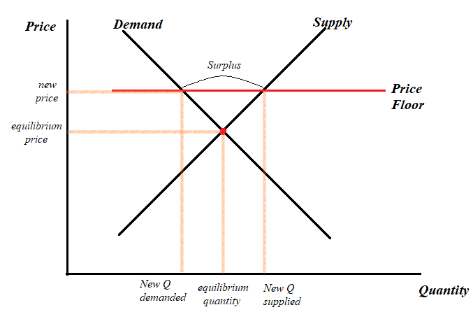

b. Yes, it is. The demand for cheese is very elastic, so consumers easily move on to other products. Therefore, this higher price leads to smaller total revenues.

c. Producers benefit because they sell more cheese at a higher price. Consumers lose because they can buy less cheese at a higher price. (indirectly, tax payers lose because the government has no money of its own to spend on cheese.)

3. a. 6 million frisbees at $8 each.

b. 2 million frisbees at $10 each (a shortage of frisbees).

c. 3 million frisbees at $7 each (a shortage of frisbees).

4. a. There is no difference between the price paid by consumers and the price received by producers

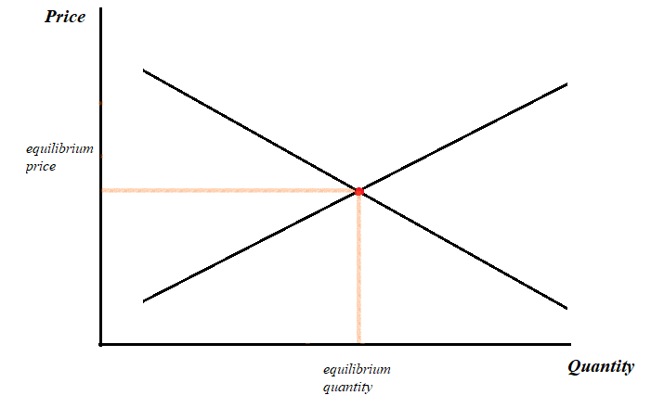

b. Consumers pay $2 more, producers receive the same price as before ($2 goes to the government). Total amount of beer sold is lower, producer total revenue is lower.

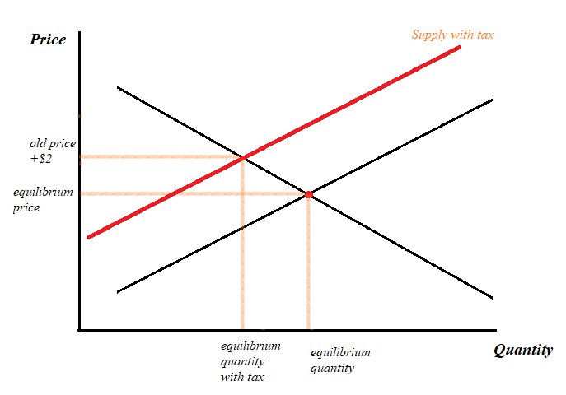

5. a.

Qs = Qd = 200

b. Replace the price in supply and demand equations. 210 units are demanded and 180 units are supplied. There’s a shortage of 30 units.

c. the price floor is below the equilibrium price, so it has no effect on the market.

d. solve the equations like before to get the equilibrium price of $120, quantity demanded and quantity supplied of 180 units. There is no shortage or surplus, but the market is smaller.

Thanks for checking out these weekly resources!

Don’t forget to check out our website for group tutoring times, video tutorials and lots of other resources: [www.baylor.edu/tutoring](http://www.baylor.edu/tutoring) ! Answers to check your learning questions are below!