**ECO 2306 – Principles of Microeconomics**

Week 7

**Hello and Welcome to the weekly resources for ECO 2306 – Principles of Microeconomics!**

**This week is Week 7 of class, and typically in this week of the semester, your professors are covering these topics below.**  If you do not see the topics your particular section of class is learning this week, please take a look at other weekly resources listed on our website for additional topics throughout of the semester.

We also invite you to **look at the group tutoring chart on our website to see if this course has a group tutoring session offered this semester**.

If you have any questions about these study guides, group tutoring sessions, private 30 minute tutoring appointments, the Baylor Tutoring YouTube channel or any tutoring services we offer, please visit our website [www.baylor.edu/tutoring](http://www.baylor.edu/tutoring) or call our drop in center during open business hours. M-Th 9am-8pm on class days 254-710-4135.

Our main resource is going to be Principles of Microeconomics by N. Gregory Mankiw.

**Topic of the week**

**Consumers, Producers, and the Efficiency of Markets**

**Keywords:** welfare economics, willingness to pay, consumer surplus, cost, producer surplus, efficiency, equality.

**Concepts:**

In this chapter we learn about **welfare economics**, which is the study of how the allocation of resources affects economic well-being. We study the benefits of engaging in market activities for buyers and sellers and learn how we can measure the total wellness of society.

**Consumer Surplus**

Let’s start with the buyers. When sellers supply something to the market, buyers have to decide how much to pay for it. The maximum amount that a buyer will pay for a good is called **willingness to pay** and determines the value of an item. Charging slightly more than this value will drive sellers out of the market. Willingness to pay is not constant. For example, a cup of coffee is worth more in the morning than at night.

Willingness to pay is where the demand curve comes from. Consumers get some benefit from buying a good and in return pay a price for it. **Consumer surplus** is the amount a buyer is willing to pay for a good minus the amount the buyer actually pays for it.



Figure 1 Consumer surplus and prices (source: Mankiw)

We can measure consumer surplus using the demand curve: The area below the demand curve and above the price determines consumer surplus. Buyers always want to pay less, so a lower price raises consumer surplus. As we know from before, a lower price also increases the size of the market.

Consumer surplus measures the well-being of the buyers in a market *as they perceive it,* and is the best measure of economic well-being as it is currently understood. If you are on the edge of ending a subscription or stopping the purchase of some product, that’s because you’re getting little to no consumer surplus.

**Producer Surplus**

Sellers have to accept a certain **cost** in order to produce something. As we learned before, cost is the value of everything a seller must give up to produce a good. **Producer surplus** is the amount a seller is paid for a good minus the seller’s cost of providing it. The supply curve is derived from the costs of suppliers and can be used to measure producer surplus.

The area under the supply curve is equal to producer surplus. In the market, an increase in prices increases producer surplus for existing sellers and adds new sellers to the market, so the total amount of producer surplus will be higher. If you are on the edge of quitting your job, it’s because you’re getting little to no producer surplus.



Figure 2 Producer surplus (source: Mankiw)

**Market Efficiency**

Imagine you can completely control the market. You decide who gets what, what businesses produce what, and what quantity should be produced. We call you the benevolent social planner or a well-intended dictator. You may decide the market equilibrium, or some other arrangement, but which?

First, you need a measure of economic well-being, know as *total surplus,* which is the sum of consumer and producer surplus, or the value to buyers minus the cost to sellers. If an allocation of resources maximizes total surplus, we say that the allocation exhibits **efficiency.** Without efficiency, some of the potential gains of trade between sellers and buyers may not be realized. You may also care about **equality**, or whether or not various buyers and sellers in the market have similar levels of economic well-being. Policy makers have to make this constant trade-off between efficiency and equality.

Under unplanned, free market conditions, the market reaches a natural equilibrium. The natural conditions that lead everyone in the market to the best outcome is known as *the invisible hand*, and maximizes economic efficiency. Therefore, free markets are the best way to organize economic activity under one very important condition: there has to be a lot of competition.



Figure 3 Total surplus (source: Mankiw)



Figure 4 efficiency of the free market equilibrium (source: Mankiw)

**Market Failure**

In real world, we may not always see perfect competition. One reason is *market power*, which is the ability of one or a small group of buyers or seller to control the prices. Also, buyers and sellers are not the only groups who benefit from the market outcomes. A classic example is pollution and other environmental damage caused by production. These problems are known as *externalities.*

Market power and externalities are examples of a general phenomenon called *market failure*, which is the inability of some unregulated markets to allocate resources efficiently. When markets fail, public policy can potentially remedy the problem and increase economic efficiency.

**What you might struggle with**

You should not rush to judgment about market failure and public policy. Despite the possibility of market failure, the invisible hand of the marketplace is extraordinarily important, and in many instances more efficiency leads to more equality. Try to observe that in real-world markets.

**Check your learning**

1. Kyra buys an iPhone for $240 and gets consumer surplus of $160.

a. What is her willingness to pay?

b. If she had bought the iPhone on sale for $180, what would her consumer surplus have been?

c. If the price of an iPhone were $500, what would her consumer surplus have been? (source: Mankiw)

2. Suppose the demand for French bread rises. Explain what happens to producer surplus in the market for French bread. Explain what happens to producer surplus in the market for flour. Illustrate your answers with diagrams. (source: Mankiw)

3. It is a hot day, and Bert is thirsty. Here is the value he places on each bottle of water:

Value of first bottle: $7

Value of second bottle: $5

Value of third bottle: $3

Value of fourth bottle: $1

a. From this information, derive Bert’s demand schedule. Graph his demand curve for bottled water.

b. If the price of a bottle of water is $4, how many bottles does Bert buy? How much consumer surplus does Bert get from his purchases? Show Bert’s consumer surplus in your graph.

c. If the price falls to $2, how does quantity demanded change? How does Bert’s consumer surplus change? Show these changes in your graph. (source: Mankiw)

4. Ernie owns a water pump. Because pumping large amounts of water is harder than pumping small amounts, the cost of producing a bottle of water rises as he pumps more. Here is the cost he incurs to produce each bottle of water:

Cost of first bottle: $1

Cost of second bottle: $3

Cost of third bottle: $5

Cost of fourth bottle: $7

a. From this information, derive Ernie’s supply schedule. Graph his supply curve for bottled water.

b. If the price of a bottle of water is $4, how many bottles does Ernie produce and sell? How much producer surplus does Ernie get from these sales? Show Ernie’s producer surplus in your graph.

c. If the price rises to $6, how does quantity supplied change? How does Ernie’s producer surplus change? Show these changes in your graph. (Source: Mankiw)

5. Consider a market in which Bert and Ernie from previous problems are the buyer and the seller.

a. Use Ernie’s supply schedule and Bert’s demand schedule to find the quantity supplied and quantity demanded at prices of $2, $4, and $6. Which of these prices brings supply and demand into equilibrium?

b. What are consumer surplus, producer surplus, and total surplus in this equilibrium?

c. If Ernie produced and Bert consumed one fewer bottle of water, what would happen to total surplus?

d. If Ernie produced and Bert consumed one additional bottle of water, what would happen to total surplus??

**Answers**

These are my answers. You should be able to come up with your own arguments that may or may not differ from mine.

1. a. $400, b. $220, c. -100 (she wouldn’t buy the phone)

2. new demand pushes the price up, old producers produce more and new producers enter the market. Total producer surplus is increased. Bread producers demand more floor, so the same thing happens in the floor market.

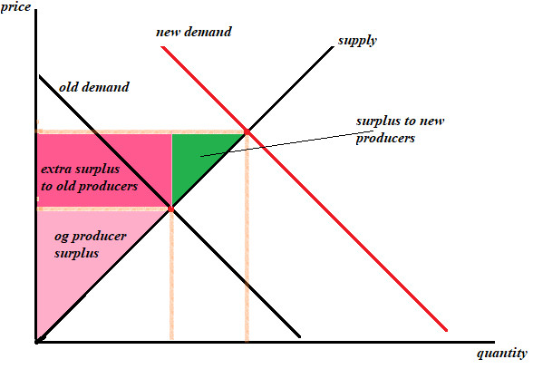

3. a. (Hint: regardless of where the demand schedule begins, always include 0 in your graph)

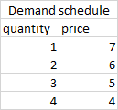 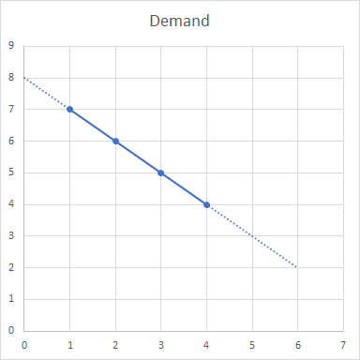

b. 4 bottles. Consumer surplus: 8

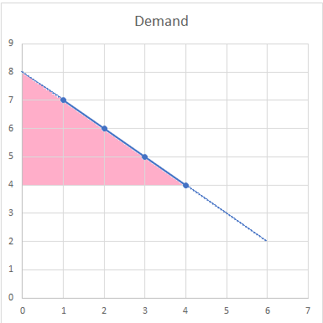

c. from extrapolating the demand curve: 6 bottles. Now he gets 18 consumer surplus: 8 extra for the original 4 bottles and 2 extra for the additional 2 bottles.

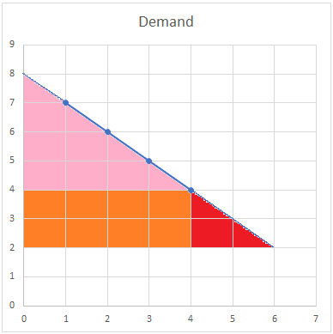

4. a.

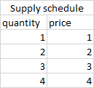 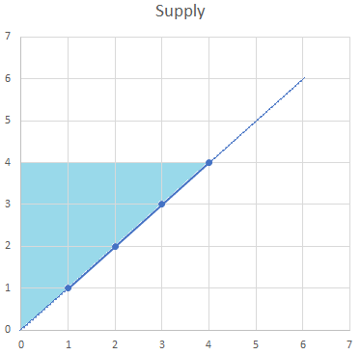

b. 4 bottles. Producer surplus: 8

c. from extrapolating the supply curve: 6 bottles. Now he gets 18 producer surplus: 8 extra from previous sales and 2 extra from new sales.

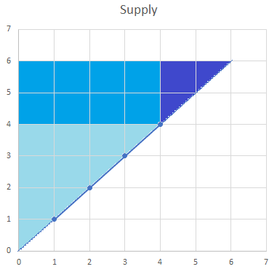

5. a. at $2: 6 bottles demanded, 2 bottles supplied. At $4: 4 bottles demanded and 4 bottles supplied. At $6: 2 bottles demanded and 6 bottles supplied. $4 is the equilibrium price.

b. producer surplus: 8. Consumer surplus: 8. Total surplus: 16.

c. total surplus would decrease to 9.

d. total surplus would increase to 25.

Thanks for checking out these weekly resources!

Don’t forget to check out our website for group tutoring times, video tutorials and lots of other resources: [www.baylor.edu/tutoring](http://www.baylor.edu/tutoring) ! Answers to check your learning questions are below!